FINAL REPORT
(F. Conte)

1. SCIENTIFIC BACKGROUND AND AIM OF THE VISIT

Genetic studies of orofacial clefts (especially cleft lip and/or palate, CL/P, and cleft palate only, CPO) in combination with other malformations have identified a number of causative genes. These genes, however, only explain a low percentage of OFC cases, suggesting that novel disease mechanisms are still waiting to be discovered. Current genetic studies, such as exome sequencing, are focused mainly on the coding regions that occupy about 2% of the genome. Considering cleft lip and/or palate (CL/P), so far a limited number of CL/P genes have been identified by exome sequencing, mainly in syndromic forms. For the more common sporadic CL/P, genome-wide association studies (GWAS) are often applied. These studies implicated variants in many genomic loci contributing to the risk of CL/P by statistical analysis, and the majority of these variants are located in the non-coding regions of the genome, where regulatory elements (REs) may be contained.
It has been shown that p63-bound regulatory elements (p63 binding sites) can drive expression of genes relevant to orofacial development and are important to etiology of OFCs (Thomason et al., 2010; Fakhouri et al., 2013). A consensus binding motif that is recognized by p63 for its binding to DNA has been identified (Kouwenhoven et al., 2010) In general, the binding motif sequence is composed of 19 nt (Fig.1), and four of them are highly conserved in p63 binding sites: C (5th nt), G (8th nt), C (15th nt) and G (18th nt).

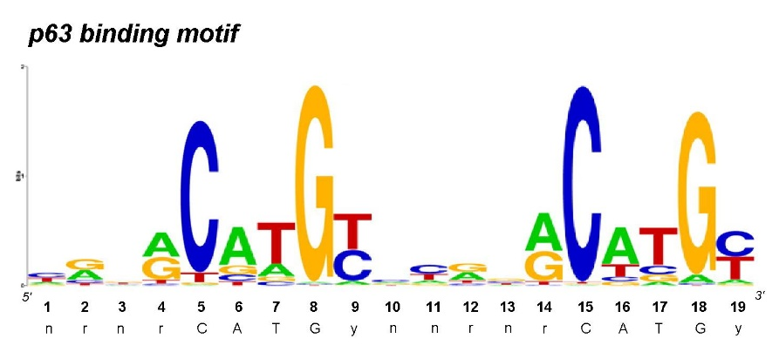

Figure 1: p63 consensus binding motif identified from 11,329 binding sites (Wolchinsky et al., 2014).

In some cases, the patients show a deletion or duplication of a wide genomic sequence which contains several different genes and REs. These large alterations, called genomic copy number variations (CNVs), have been reported to associate with syndromic and non-syndromic forms of OFCs using various genetics analyses such classical FISH, CGH arrays or more recently SNP arrays (FitzPatrick et al., 2003; Mulatinho et al., 2008; Barber et al., 2013; Izzo et al., 2013). Most of these studies are reports of single cases with large genomic variants in which the causative genes or REs are often not clear. [here you can insert the p63 part from above]
With the current development of genomics and diagnostic tools, CNV data of patients are accumulating and many are deposited in online databases. Therefore, a systematic analysis of all reported CNVs associated with OFCs may identify common genomic regions including genes and regulatory elements and shed lights on causative elements and common molecular pathways involved in OFCs.

The objective of our project is to perform a bioinformatics analysis by comparing and intersecting CNV regions found in cleft patients recorded in two online databases, DECIPHER and ECARUCA (Fig.2) to identify causative genes and p63 –bound REs that can play a rule in OFC etiology.
The analysis pipeline includes patients’ selection, the CNV data collection, analysis to identify overlapping genomic regions with deletions or duplications shared among cleft patients. Subsequently, these regions were prioritized at different levels, considering multiple criteria to assess whether they are likely associated with cleft phenotypes. Finally, the genes and p63 regulatory elements contained in the overlapping regions were separately investigated and prioritized, to assess the most likely causative elements for clefting.

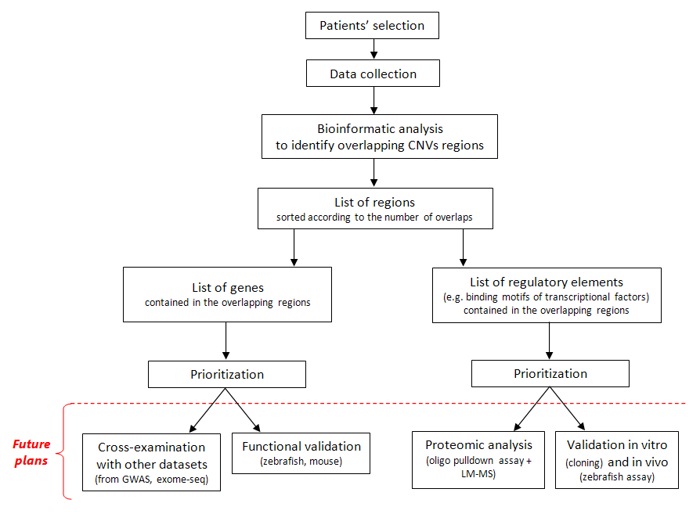

Figure 2: Project workflow.

2. WORK DESCRIPTION AND RESULTS

  - Bioinformatic analysis of overlapping CNV regions

    - CNVs databases used in our study

Patients included in our study were retrieved from two freely-available CNV databases: DECIPHER and ECARUCA.
DECIPHER (https://decipher.sanger.ac.uk/) is a specific database of chromosomal imbalance and phenotype in human, based on Ensembl Resources. Contributing to DECIPHER is an International Consortium of more than 200 academic clinical centers of genetic medicine and 1600 clinical geneticists and diagnostic laboratory scientists, belonging to 30 different Countries (Bragin et al., 2014). At the time of writing this report, in this database are recorded more than 10,000 clinic cases and over 25,000 patients: of these, about 300 patients present cleft phenotype, including CL, CLP, CPO, alveolar ridge cleft and other types.
Similarly, ECARUCA (European Cytogeneticists Association Register of Unbalanced Chromosome Aberrations, www.ecaruca.net) is another CNV database that collects and provides detailed clinical and molecular information on rare unbalanced chromosome aberrations. So far, ECARUCA contains over 4800 cases with a total of more than 6600 genetic aberrations and has over 3000 account holders worldwide (Vulto-van Silfhout et al., 2013). In these second database we found only 17 OFC patients with CNV array data available.

    - Patient selection and data collection

The first step of our project was to select the patients according to their orofacial cleft phenotype and the availability of their CNV data. So far, our study includes 312 patients affected by OFCs (Table 1), 295 from DECIPHER and 17 from ECARUCA. Their genomic CNV regions were analyzed in order to identify the overlapping regions (common deleted or duplicated regions). Although the etiologic bases and developmental processes may vary depending on the cleft type, initially we decided to include patients with different OFCs (mixed population) in order to reach a larger cohort. To give an overview, the group of CPO patients was the greatest in number (186), followed by the group of CLP patients (41), and then the one of BF patients’ (30) and CL patients’ group (26), while the patients affected by other types of orofacial clefts have smaller numbers.

Phenotypes | Num. of patients | More info
Cleft lip (CL) | 26 | One patient is affected by lower lip cleft
Cleft palate (CPO) | 186
CPO + Bifid uvula | 8
Cleft lip and palate (CPL) | 41 | One patient is affected by CLP + cleft mandible
CLP + Bifid uvula | 1
Bifid uvula (BF) | 30
Oral cleft (unspecified) | 10
Facial cleft (unspecified) | 1
Facial cleft (unspecified) + CP | 1
Alveolar ridge cleft | 2
Alveolar ridge cleft + CL | 3
Alveolar ridge cleft + CPO | 1
Cleft mandible + CL | 2

Table 1: Cohort of OFC patients (312) recorded in DECIPHER and ECARUCA databases. The classification is based on
their cleft phenotypes, which refer to the data inserted by the clinicians in those databases. For enlarging the
cohort, we have decided to consider a mixed population, including patients with different types of OFCs.

After selecting the relevant subjects, we gathered patients’ details (ID num., cleft type and other phenotypes, presence of syndromes) and CNV information (CNV type, genomic location, size, num. of involved genes) from the databases. Subsequently, patients’ CNVs were grouped in two lists based on the type, deletion (DEL) or duplication (DUP), in order to work with them separately.

    - Analysis of overlapping genomic regions

To indentify overlapping genomic regions in these patients’ CNVs, Galaxy platform has been used. The term overlapping region is indicated in Fig.2.

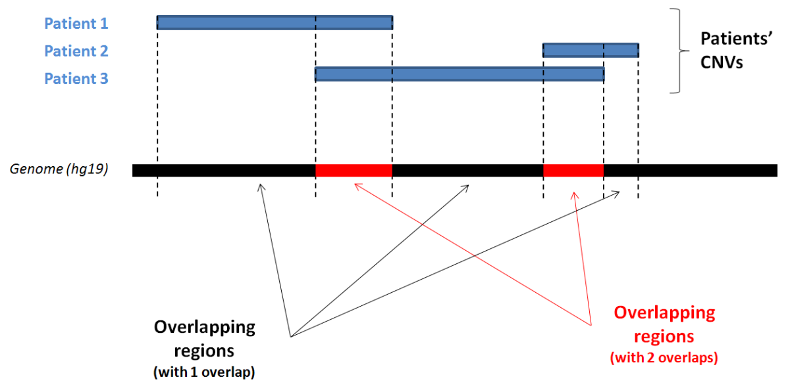

Figure 2: Example of overlapping process.

Two lists of overlapping genomic regions (one for overlapping DELs and one for overlapping DUPs) were generated, comprising of their genomic coordinates and number of overlaps.
According to our hypothesis, those overlapping regions which are affected by a chromosomal aberration (deletion or duplication) in a high number of cleft patients may contain genes or regulatory elements that more likely contribute to OFCs development. For this reason, a sorting of the overlapping regions based on the number of overlaps, was performed to highlight the most informative ones in our lists., Altogether, two genomic regions with duplications were found to be shared in eight cleft patients (highest for duplication regions) and one genomic region with deletion in other eight cleft patients (highest for deleted regions).

Subsequently, as the overlapping regions are in general large and contain both coding and non-coding sequences, we analyzed both coding and non-coding regions separately in order to search for genes and regulatory elements (Fig.1).

- Gene selection

The genes contained in overlapping regions were determined by combining UCSC Table Browser (UCSC Genome Browser, http://genome.ucsc.edu/) and Galaxy tools, setting human genome GRCh37/hg19 as assembly. A list of RefSeq genes that are either deleted (5812) or duplicated (5941) in CNVs was generated (Fig.3).
The genes of this list were prioritized based on (a) the number of patients with these CNVs and (b) the size of the genomic regions of these CNVs. Firstly, genes that are deleted or duplicated in only one patient were excluded. Afterwards, genes in overlapping regions that contained less than five genes in total were separated to those in overlapping regions containing six or more genes (arbitrary cut-off value), creating a sub-lists of about one hundred top genes (113 genes from DELs; 88 genes from DUPs).
In theory, the regions with a high number of overlaps and a low number of genes should be more informative that the regions overlapped by a few patients or containing many genes, because small regions shared in several patients may contain genes which were most likely crucial for cleft etiology during embryogenesis in those subjects.

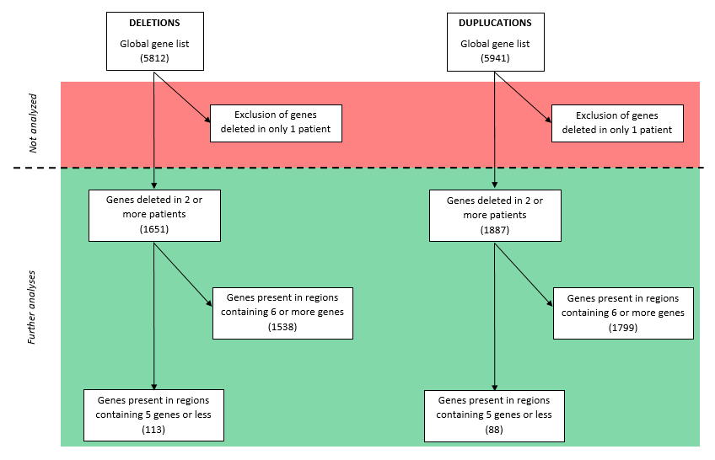

Figure 3: Prioritization and selection process applied to the gene lists derived from overlapping deletions and overlapping duplications.

The resulting sub-lists were prioritized using ENDEAVOUR (http://www.esat.kuleuven.be/endeavour), an online tool for prioritizing variants based on the prediction of candidates by analyzing inherent sequence characteristics, sequence similarity to known disease genes and functional annotation of candidate genes. To run the prioritization, this software required a training-list composed of reference genes. In our case, we chose a set of genes that have been shown to be related with OFCs development (Table 2)(Dixon et al., 2011).

Gene official symbol | Ensembl gene ID | Reference
IRF6 | ENSG00000117595 | Dixon et al., 2011
VAX1 | ENSG00000148704 | Dixon et al., 2011
MSX1 | ENSG00000163132 | Dixon et al., 2011
FOXE1 | ENSG00000178919 | Dixon et al., 2011
MYH9 | ENSG00000100345 | Dixon et al., 2011
MAFB | ENSG00000204103 | Dixon et al., 2011
ABCA4 | ENSG00000198691 | Dixon et al., 2011
BMP4 | ENSG00000125378 | Dixon et al., 2011
FGFR2 | ENSG00000066468 | Dixon et al., 2011
TGFA | ENSG00000163235 | Dixon et al., 2011
TGFB3 | ENSG00000119699 | Dixon et al., 2011
MTHFR | ENSG00000177000 | Dixon et al., 2011
GSTT1 | ENSG00000184674 | Dixon et al., 2011
PDGFC | ENSG00000145431 | Dixon et al., 2011
FGF8 | ENSG00000107831 | Dixon et al., 2011
PVRL1 | ENSG00000110400 | Dixon et al., 2011
SUMO1 | ENSG00000116030 | Dixon et al., 2011
CRISPLD2 | ENSG00000103196 | Dixon et al., 2011
MEIS2 | ENSG00000134138 | Johansson et al., 2014
SATB2 | ENSG00000119042 | Döcker et al., 2014
TBX1 | ENSG00000184058 | Funato et al., 2014

Table 2: Training list used in ENDEAVOUR for genes prioritization.

Then, the analysis was run on the basis of a three step algorithm: (1) the program collected all the data about pathways and diseases in which the genes are involved, accessing up to twenty sources (to mention a few: GeneOntology, SwissProt, BioGrid interactions, ProspectR, BLAST score protein, etc.); (2) for each source, the candidates were ranked according to their similarities, so a set of n rankings was generated (one per data source); (3) the n rankings were combined into one global prioritization list of candidate using the order statistics.

From the resulting prioritized lists of genes, the first 25 genes were further analyzed (Table 3; Table 4) by examining whether these candidates were already known OFC genes (PubMed, OMIM) and, if not, the presence of known OFC genes in the same overlapping CNVs. On the top of the gene lists, we found several known cleft-related genes. In the list from overlapping deletions (Table 3), eight were known cleft genes (MEIS2, SABT2, FGF2, TSHZ1, FRZB, SPRY1, WHSC1, WHSC2). In the list from overlapping duplications (Table 4), five were known cleft genes (TBX1, MAPK3, CYFIP1, DGCR6 and GNB1L). These data show that our methodology can identify OFC causative genes. Interestingly, we also identified some novel genes that are not yet known to be associated with OFCs. In the list from overlapping deletions (Table 3),

17 were new candidates, and in the list from overlapping duplications (Table 4), 20 were novel new candidates.

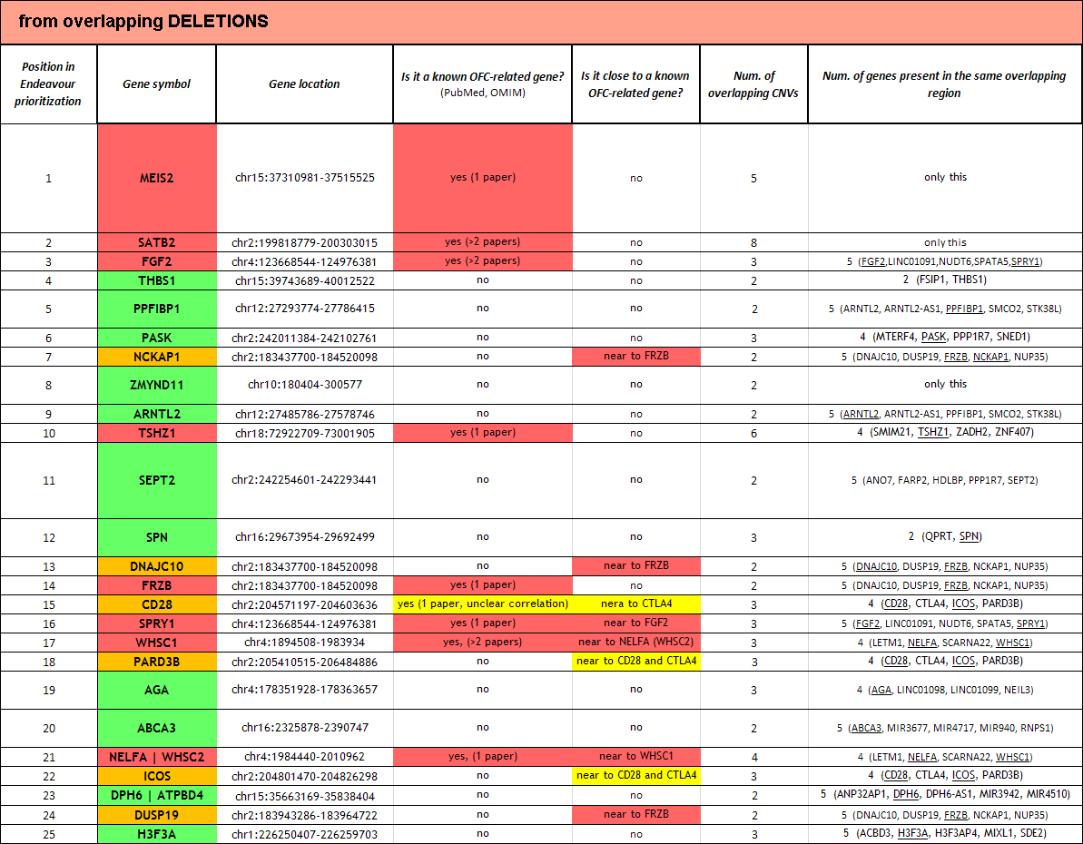

Table 3: First 25 top genes from overlapping deletions. For each gene, the position in ENDEAVOUR rank is reported in column (1), the official gene symbol in column (2) and the location in column (3). In column (2) the genes already proved to be associate with OFCs are highlighted in red, in green are indicated the possible new causative genes and in orange the new genes located close to known cleft genes. In column (4) it is specified if the candidate is known to be associated with OFCs in literature (red), if they are suspected to be related with OFCs (yellow) or if nothing is already published on it. In column (5), the proximity between the candidate and known cleft genes is reported (in theory, if an interesting new gene is located near a known cleft gene, probably the cleft phenotype is due to the known gene rather than the new one). In column (6) the number of overlaps are scored, indicating in how many patients that gene is deleted. Finally, in column (6) the other genes present in the same overlapping deletion of each candidate are shown.

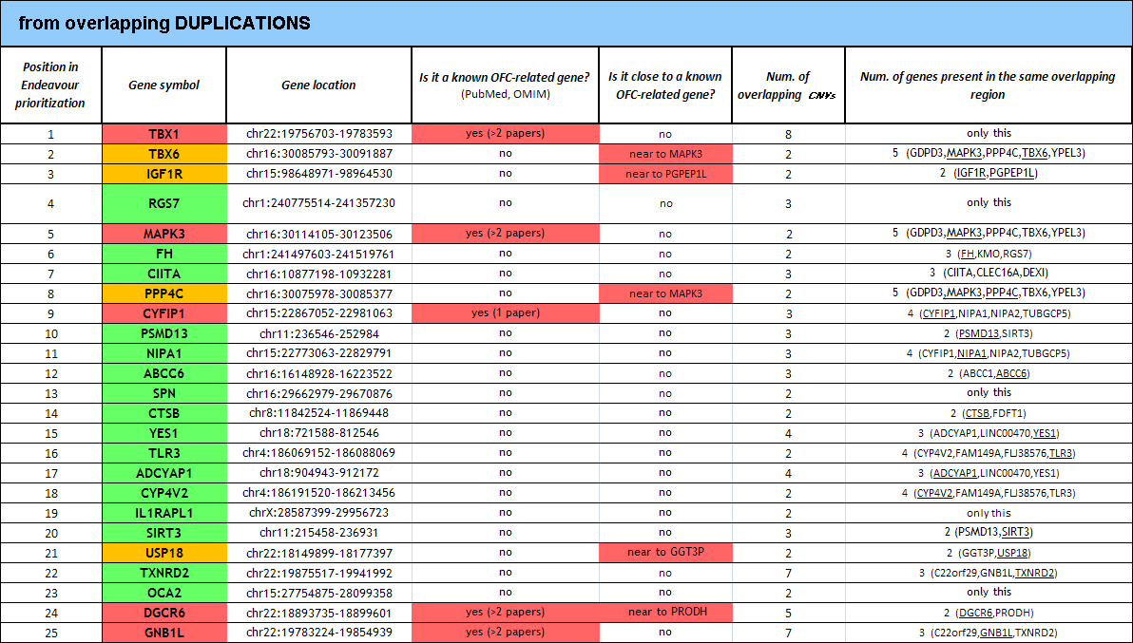

Table 4: First 25 top genes from overlapping deletions. For each gene, the position in ENDEAVOUR rank is reported in column (1), the official gene symbol in column (2) and the location in column (3). In column (2) the genes already proved to be associate with OFCs are highlighted in red, in green are indicated the possible new causative genes and in orange the new genes located close to known cleft genes. In column (4) it is specified if the candidate is known to be associated with OFCs in literature (red), if they are suspected to be related with OFCs (yellow) or if nothing is already published on it. In column (5), the proximity between the candidate and known cleft genes is reported (in theory, if an interesting new gene is located near a known cleft gene, probably the cleft phenotype is due to the known gene rather than the new one). In column (6) the number of overlaps are scored, indicating in how many patients that gene is duplicated. Finally, in column (6) the other genes present in the same overlapping deletion of each candidate are shown.

To better clarify how these genes could be involved in OFC developmental process, others databases were used to collect details about their functions in human, such as DAVID (Database for Annotation, Visualization and Integrated Discovery, david.abcc.ncifcrf.gov/) and GeneCards (www.genecards.org/).

The list of new candidate genes in the deleted regions (Table 5) includes a structural protein (THBS1), two transcriptional factors (ZMYND11 and ARNTL2), two transporters (DNAJC-10 and ABCA3), three metabolic enzymes (PASK, AGA and DPH6) and four proteins related with different developmental processes (PPFIBP1, NCKAP1, SEPT2 and PARD3B) which were as many as the receptors/co-receptors (SPN, CD28, ICOS and DUSP19).

In general, because OFCs can derive from a misregulation of neural crest development during embryogenesis, we focused firstly on proteins that are related to this pathway. Particularly interesting proteins were PARD3B which plays roles in asymmetrical cell division (typical of stem cells) and cell polarization processes, and SEPT2 involved in cytoskeleton organization, in polarized structure formation and mitosis. In addition, PPFIBP1 and NCKAP1 seemed to be associate with embryonic processes, since the first drives the formation of glands and neuronal structures (e.g. axon) while the second regulates lamellipodia formation in cells, modifying their migration ability. Furthermore, also the two transcriptional factors, ZMYND11 and ARNTL2, could increase or decrease the express of genes belonged to pathways related with embryogenesis.

Among the new top genes (20) in the overlapping duplication regions (Table 6), we found two transcriptional factors (TBX6 and CIITA), four receptors (IGF1R, SPN, TLR3 and IL1RAPL1), four proteins involved in signalling pathways (RGS7, PPP4C, YES1 and ADCYAP1), four the metabolic proteins (FH, CYP4V2, SIRT3 and TXNRD2), and three transporters (NIPA1, ABCC6 and OCA2) as many as proteinases related to cellular degradative pathways (PSMD13, CTSB and USP18). Focusing on the proteins that are related with embryogenesis and, in particular, with neural crest-deriving structure development, the most interesting seemed to be TBX6, a regulator of developmental process regulators that determine the fate of axial stem cells, and YES1, a kinase involved in cell growth processes, apoptosis and cell-cell adhesion. In addition, SIRT3 and PPP4C have functions in chromatin acetylation, modulating the chromatin accessibility through developmental stages, and therefore they could be related to developmental processes,

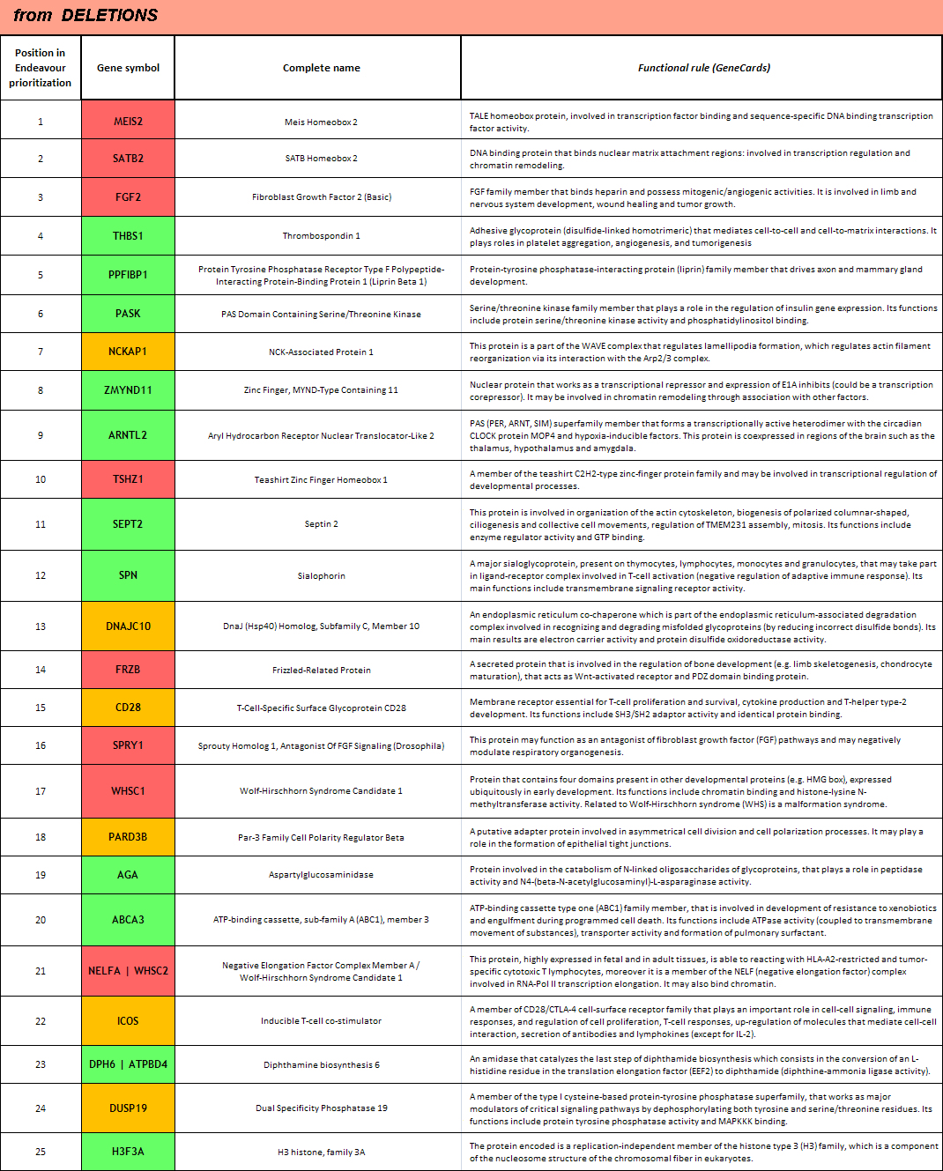

Table 5: Names and functions of the top candidate genes coming from the analysis the overlapping deletions. Starting from the right side, in column (1) is reported the position of the gene in ENDEAVOUR ranking. In column (2) are listed the gene symbols: in red are indicated those genes already proved to be associate with OFCs, in green the possible new causative genes and in orange the new genes that are located close to known cleft genes. In column (3) it is specified the name of each codified protein. In column (4) there is a summary for each protein about its main functions.

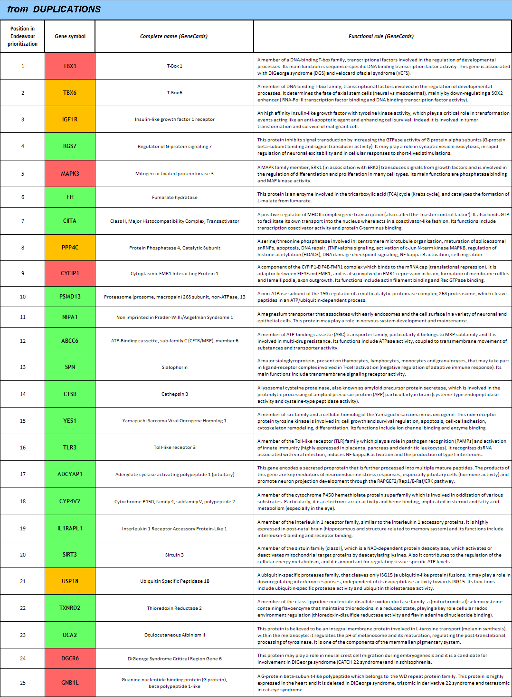

Table 6: Names and functions of the top candidate genes coming from the analysis the overlapping duplications. Starting from the right side, in column (1) is reported the position of the gene in ENDEAVOUR ranking. In column (2) are listed the gene symbols: in red are indicated those genes already proved to be associate with OFCs, in green the possible new causative genes and in orange the new genes that are located close to known cleft genes. In column (3) it is specified the name of each codified protein. In column (4) there is a summary for each protein about its main functions.

To check also the expression of these genes in orofacial development, we checked RNA-seq data from developing mouse palates generated by Prof. M.Dixon’s group (Manchester Academic Health Sciences Centre, University of Manchester, unpublished data).
In the deletion list, four candidates (Table 7) were highly expressed with different expression levels during development (E10-14) in this tissue, suggesting that their importance in palate development. NCKAP1 is expressed at the highest level in among these four genes, showing stable elevated levels for all the analyzed stages with the maximum peak at E14. SPET2 showed similar expression trend with the highest expression at E14. In contrast, PASK appeared to be more expressed in the early stage E10 and then its expression decreased progressively, where at E14 the level of expression was halved compare to that at E10. Similarly, THBS1 showed an overall decreasing expression.
In the context of duplication analysis (Table 8), we posited that extra copies of a gene relevantly expressed in a embryonic tissue, and hence important for its developmental processes, could cause a pathway misregulation that leaded to defects in tissue architecture. Among the new duplicated candidates, only one highly expressed gene, FH, showed an increasingexpression reaching the expression peak at E14. On the contrary, PPP4C and PSMD13 showed decreasing expression. Also IGFR1 expression reflected a global reduction from early to late stages. Interestingly, CTSB appeared to be the highest expressed new gene among all the candidate lists.

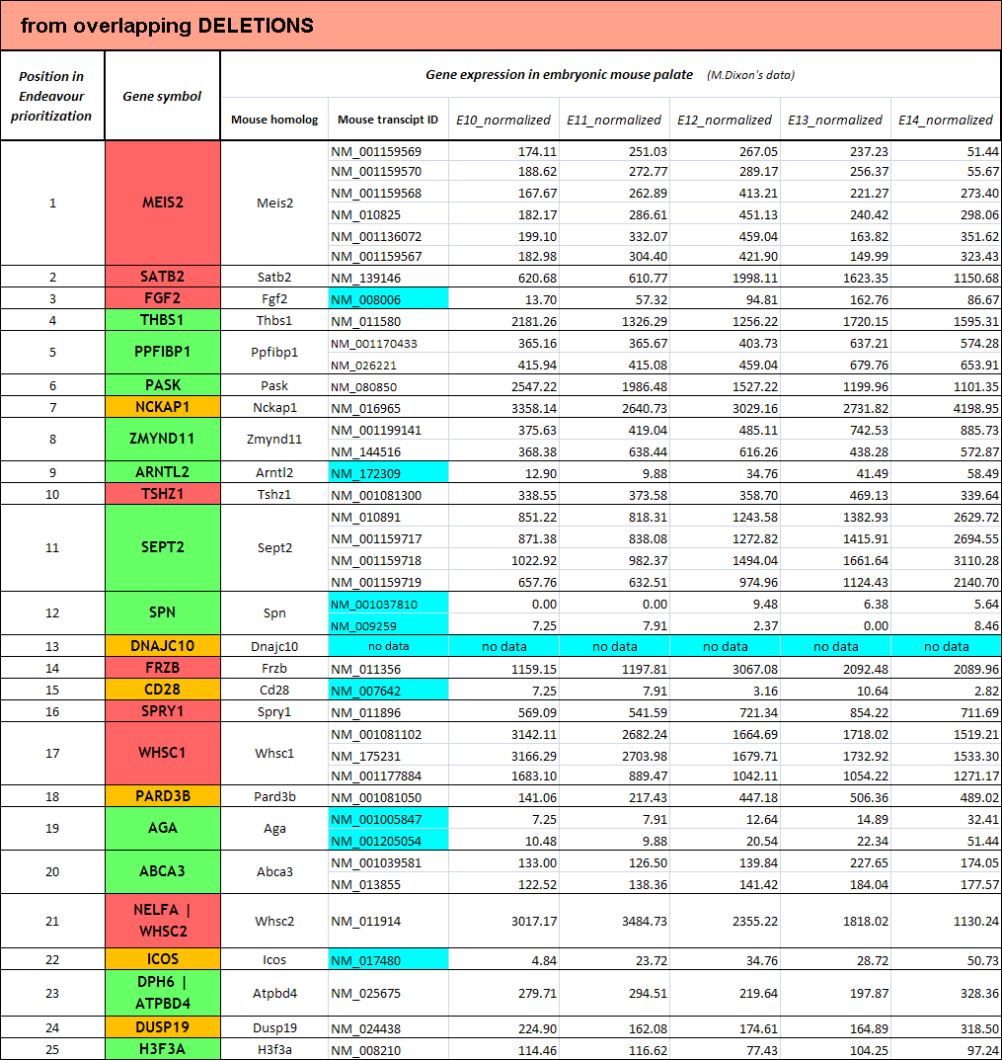

Table 7: List of the top 25 candidates from overlapping deletions, prioritized using ENDEAVOUR. Starting from the right side, in column (1) is reported the position of the gene in ENDEAVOUR ranking. In column (2) are listed the gene symbols: in red are indicated those genes already proved to be associate with OFCs, in green the possible new causative genes and in orange the new genes that are located close to known cleft genes. Column (3) contains the mouse homolog names and column (4) the mouse mRNA IDs. From column (5) to (9) the data about the gene expression in embryonic mouse palate are shown (based on M.Dixon’s data): column (5) contains the normalized expression values at stage E10, column (6) refers to stage E11, column (7) to stage E12, column (8) to stage E13 and finally column (9) refers to stage E14. In these last five columns, light blue color indicated a low or absent expression.

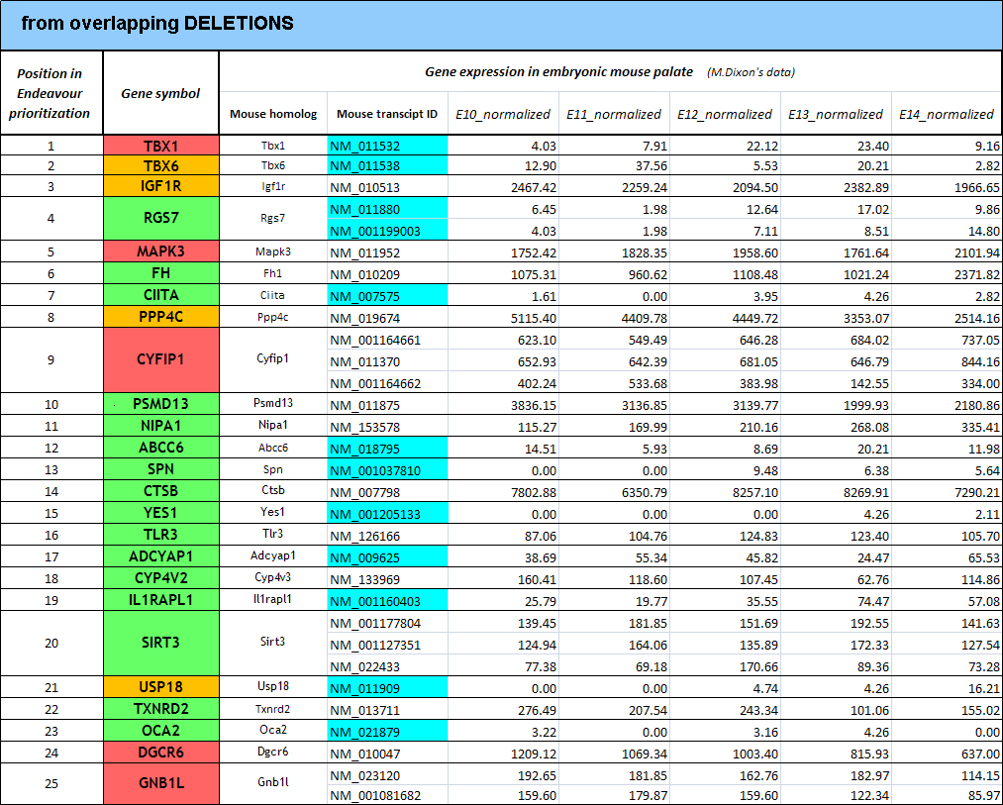

Table 8: List of the top 25 candidates from overlapping duplications, prioritized using ENDEAVOUR. Starting from the right side, in column (1) is reported the position of the gene in ENDEAVOUR ranking. In column (2) are listed the gene symbols: in red are indicated those genes already proved to be associate with OFCs, in green the possible new causative genes and in orange the new genes that are located close to known cleft genes. Column (3) contains the mouse homolog names and column (4) the mouse mRNA IDs. From column (5) to (9) the data about the gene expression in embryonic mouse palate are shown (based on M.Dixon’s data): column (5) contains the normalized expression values at stage E10, column (6) refers to stage E11, column (7) to stage E12, column (8) to stage E13 and finally column (9) refers to stage E14. In these last five columns, light blue color indicated a low or absent expression.

In conclusion, we prioritized candidate genes according to their known functions and expression in embryonic mouse palate. they need to be further investigated for their contribution to OFC development (see chapter 3, “Future plans and publications”).

- Regulatory element selection

To understand whether the overlapping genomic CNV regions contain regulatory elements, especially those bound by p63, we performed analysis to search for p63-bound regulatory elements in CNV regions by using UNIX BEDtools (http://bedtools.readthedocs.org/) and p63 ChIP-seq datasets provided in the host lab (E.Kouwenhoeven, K.Khandelwal).
In the host lab, p63 binding motifs that contain SNPs in any of four important positions (Fig. 1) have been identified (K.Khandelwal). Intersecting the motif list with our list of overlapping regions, several regions that contain p63 binding motifs were identified (Table 9). Subsequently we prioritized them according to the number of overlaps of these region in patients. Briefly, we found 43 p63 binding motifs present in overlapping CNVs with 3 overlaps or higher. Particularly, on the top of this prioritized list of binding motifs, six motifs appeared to be shared in seven patients: two of them were present in two different duplicated regions both located on chr22, other three motifs were contained in the same deleted region on chr18 while the last one was found in another deletion on chr2.
Interestingly, deletions on chr18 are not related with any syndrome including cleft in its features, suggesting the possible location of a new region which could be likely associated with OFCs. To support our hypothesis, further analyses have to be carried out on this specific region, for instance based on proteomic approaches such as oligo pulldown assay followed by mass spectrometry.

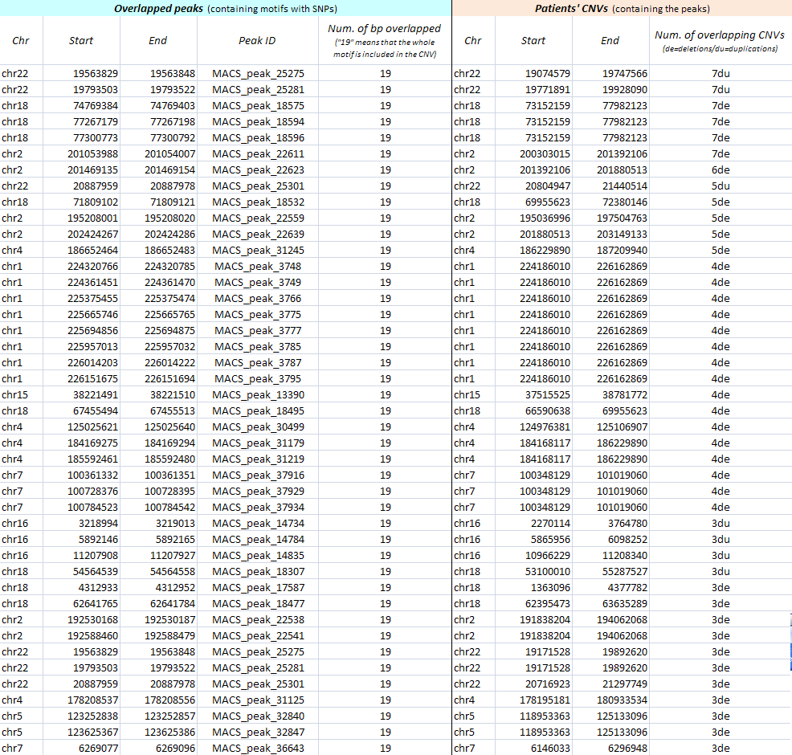

Table 9: List of p63 binding motifs belonged to the overlapping regions with the highest number of
overlaps (from 8 to 3). (In column I: “de” indicates deletions and “du” indicates duplications).

2.2. To establish Oligo pulldown assay (+ mass spectrometry) protocol

The DNA pulldown followed by mass spectrometry assay is a method to detect all the DNA-binding proteins which bind a specific sequence of DNA specifically. As p63-bound regulatory elements are relevant to etiology of OFCs (Thomason et al., 2010; Fakhouri et al., 2014), it is important to identify proteins that can cooperate with p63 during orofactial development. Therefore, we decide to establish the oligo pulldown assay protocol using p63 binding motifs. This method could identify transcriptional factors that recognize the same consensus sequences on the DNA. In these experiments, oro-epithelial cells were used to identify proteins that may be important for orofacial structure. The DNA oligo are labeled with biotin. After the incubation with oro-epithelial cell nuclear extract the oligo and all the proteins bound on it were recovered by using immobilized sepharose beads coated with streptavidin. Afterwards, peptides bound to the oligos were eluted and analyzed by western blot or, as in our case, by mass spectrometry (LM-MS). The mass spectrometry detection is a highly sensitive method, and can detect all proteins that bind to specific sequences.
In the host lab, a “combined samples” protocol (unpublished data) has been developed where oligos with different sequences can be differently labelled and compared. In our experiments, we designed oligos with p63 motif wild type sequences (wt motif) and mutated sequences (mutant motif) and compared proteins that can be pulled-down differentially. This method measures for each peptide the strength of its bound to the WT oligo (control) and the strength of its bound to the MUT oligo, calculating a final ratio.

At the beginning of the experiments, we encountered a problem of low efficiency in the nuclear extraction phase. In the host lab a nuclear extraction protocol was standardized for cancer cells, and we were gingival keratinocytes (GKs) from healthy subject biopsies (primary culture).
In general, GKs are less proliferative than standard cancel cell lines. Moreover, GKs nuclei are smaller than the cancer cell nuclei, suggesting that also the amount of nuclear material is lower.
For all these reasons, firstly we decided to modify and adapt both the culture conditions and nuclear extraction protocol, in order to optimize the efficiency for reaching a higher amount of GK nuclear extract (Table 10). Briefly, in the culture protocol we increased the amount of medium added per dish and the frequency of its refreshing for supplying more nutrients to the proliferating GKs. Afterwards, in the nuclear extraction protocol we optimized the harvesting by using trypsinization instead of cell lifter which caused a considerable loss of material breaking the cells during the scrapping step. Additionally, for the mechanical lysis of GKs, we increased the series of douncer strokes reaching a higher amount of intact nuclei and a lower contamination by plasmatic proteins.

GK primary culture protocol, modifications:
increasing of medium amount per Petri dish (15cm²) during the culturing.
increasing of the frequency of medium refreshing (every day, starting from day 5).
Nuclear extraction protocol, modifications:
increasing the amount of trypsin to cover homogenously all the surface for detaching GKs.
increasing the time of trypsinization.
doubling the steps of dish rinsing after trysinization.
increasing the volume of fresh medium to block the reaction after trypsinization.
Increasing the number of douncer strokes during mechanical lysis of GKs.

Table 10: Modifications of primary culture and nuclear extraction protocols for gingival keratinocytes.

In conclusion, we were able to reach a concentration of 4.8 mg/ml (fluorometric quantitation at A = 595nm), and a concentration of 5 mg/ml of nuclear protein is considered as the optimum,

Afterwards, we started working on oligo pulldown assay followed by mass spectrometry for adapting the protocol
to our experimental conditions. The p63 binding motif chosen for testing the host lab oligo pulldown protocol was selected byK.Khandelwal. This binding motif is affected by a SNP (rs7557989) at one of the important positions (nt 13) in LD with a GWAS locus (Fig.4). This p63 motif is located in the short arm of chr2 and overlaps with THADA.

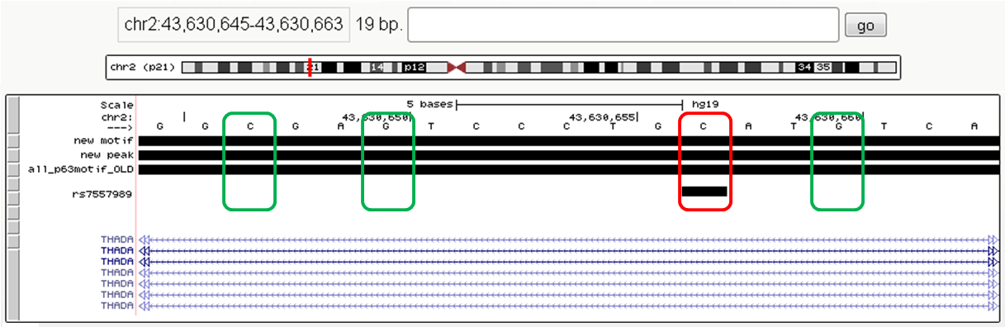

Figure 4: Screenshot from UCSC Genome Browser Custom Track (http://genome.ucsc.edu/), displaying the p63 binding motif affected by a SNP (rs7557989) in 13th position, where the C is replaced by a G (indicated in red). The other three important bases of this motif correspond to the canonical motif sequence (indicated in green). The black bars represent ChIP-seq datasets (p63 binding sites/motifs) while the blue lines indicate the different transcripts of THADA gene.

We designed three oligo pairs containing: (a) wildtype p63 motif (WT oligo); (b) all four conserved Cs and Gs mutated (AM oligo); (c) the SNP C/G on 13th nucleotide (SNP oligo). The samples with the different oligos where organized as follows: (1) WT oligo reaction mixed with SNP oligo reaction; (2) WT oligo reaction mixed with AM oligo reaction. Before the sample mixing, all the reactions were differentially labelled to make the peptides distinguishable during LM-MS detection (Fig.5). Two sets of experiments were performed, “WT oligo vs. SNP oligo” and “WT oligo vs. AM oligo”, to identify proteins that can preferentially bind to WT oligos together with p63.

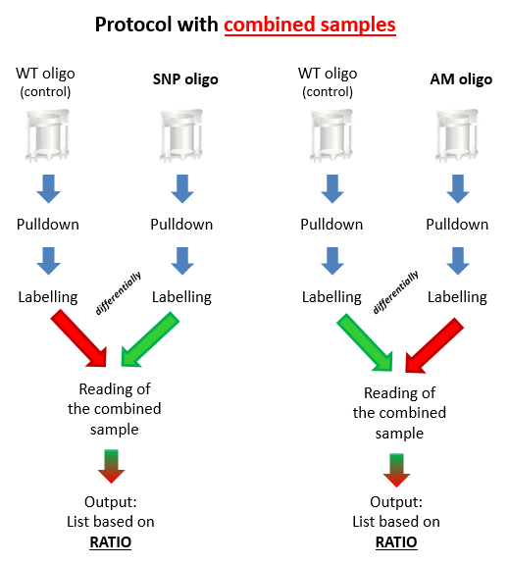

Figure 5: Workflow of oligo pulldown followed by LM-MS (“combined samples” protocol).

The result of the experiment “WT oligo vs. SNP oligo” showed many DNA-binding factors bound to the wildtype p63 motif sequence, and among these, p63 was a significant outlier (Fig.6). This result showed that p63 binds to the WT motif preferentially in comparison to the motif containing the SNP.

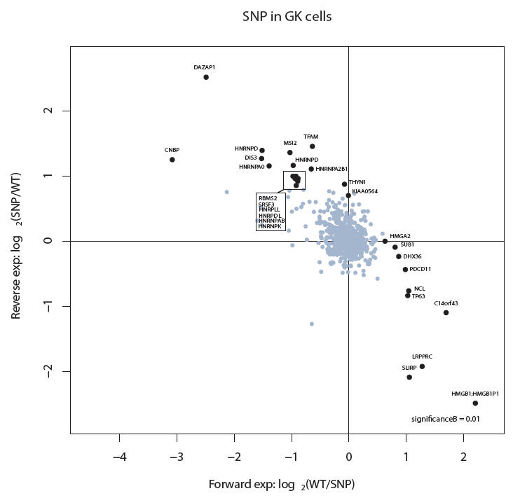

Figure 6: The experiment “WT vs. SNP” was repeated twice: once for the forward experiment and once for the reverse experiment. The North-West quadrant represents the location of all the DNA-binding proteins that bound preferentially the SNP oligo. On the other hand, the South-East quadrant contains the DNA-binding proteins that bound preferentially the WT (control) oligo. The background cloud located in the middle of the axes contained the DNA-binding proteins which bound equally both the control and the mutant, and also the factors which didn’t bind anything. The outliers spots in the quadrant represents the interesting factors (significance = 0.01). Usually the RNA-binding proteins jumps out randomly as outliers. In this case, TP63 is located in the WT quadrant (red arrow) as a significant outlier, confirming what we expected.

In the experiment “WT oligo vs. AM oligo”, p63 was not among the significant proteins that can be differentially pulled down by the oligos (Fig.7).. This could be due to technical problems

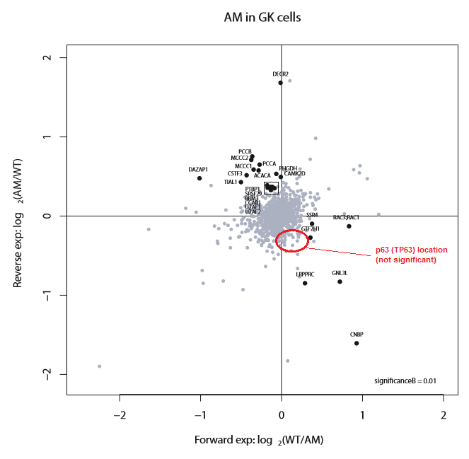

Figure 7: Plot from the third attempt of the experiment “WT vs. AM”. In this case the reaction was performed twice: once for the forward experiment and once for the reverse experiment. The North-West quadrant represents the location of all the DNA-binding proteins that bound preferentially the AM oligo. On the other hand, the South-East quadrant contains the DNA-binding proteins that bound preferentially the WT (control) oligo. The background cloud located in the middle of the axes contained the DNA-binding proteins which bound equally both the control and the mutant, and also the factors which didn’t bind anything. The outliers spots in the quadrant represents the interesting factors (significance = 0.01). Usually the RNA-binding proteins jumps out randomly as outliers. In this case, TP63 is not present in the WT quadrant but in the background cloud.

3. FUTURE PLANS AND PUBLICATIONS

3.1. Future bioinformatic work

As statistics has not been applied to the current bioinformatics analysi, a non-parametric statistical validation of our bioinformatic approach should be performed to demonstrate that the overlapping region distribution among the chromosomes is not due to the contingency. About that, we also think that could be interesting to modify the cohort of OFC patients, for example, to excluding syndromic cases and to examine how the distribution of overlaps changes and whether some overlapping regions could be specifically related with non syndromic forms.
Moreover, the lists of candidate genes can be applied to two downstream analyses, to cross-check genes identified with other techniques: (a) cross-examination between these prioritized gene lists and the candidates identified by exome-seq analysis carried out on 10 Dutch cleft families in the host lab (C.Ockeloen, and K.Khandelwal); (b) cross-checking of overlapping regions and GWAS dataset (Dr. K.Khandelwal). This is to test whether our method can be used for prioritization for exome sequencing studies for OFC.
Another bioinformatic analysis that could be performed is to check whether these selected candidate genes are directly regulated by p63, using p53FamTag database and many ChIP-seq datasets generated in the host lab (E.Kouwenhoeven), because the presence of p63 targets can highlight a stronger relation between those genes and clefting.
Furthermore, we have identified several miRNA genes in our high priority lists. This suggests a possible association of non-coding RNA with cleft-related processes, such as embryo morphogenesis, neural tube development, cell migration and proliferation, skeletal development. To test this hypothesis, we are planning to use other bioinformatic tools and miRNA databases for collecting data systematically and perform a prioritization process to investigate which miRNA may be cleft-related.

3.2. Functional validation of top genes

Concerning the genes identified through our computational analysis, we could evaluate their expression and tissue specificity in human by checking online databases (e.g. Ensembl tools). In addition, their contribution in clefting can also be tested in animal models such as zebrafish and mouse.

3.3. Validation of selected p63 motifs

In the context of regulatory elements, we could apply systematically the oligo pull-down assay followed by LM-MS to investigate other p63 binding motifs, such as those identified through the computational analysis in the overlapping regions. For instance, we could select the p63 motifs which present SNPs in linkage disequilibrium with OFCs and, using this proteomic approach, to investigate the mutation effects on p63 bound and activity. Subsequently, we could carefully the lists of DNA-binding factors that bind the oligos containing p63 binding motif, to evaluate their similarity and to look for possible cofactors. In relation to this aspect, also another type of pulldown, the so called antibody pulldown assay, could be performed to identify the real cofactors of p63, which are still unknown.
Furthermore, the selected p63 binding motifs can be tested in vitro, through cloning approaches (transient
transfection assay) and in vivo using animal models. The prioritized p63 binding sites will be cloned into Gateway system vectors for transient transfection assay in human cell lines and in transgenesis in the zebrafish model (in collaboration with J.L. Gomez-Skarmeta, CABD Sevilla). These experiments aim at understanding whether these p63 binding sites drive gene expression during orofacial development.

3.4. Future publications

Once the statistic analysis of the distribution of overlapping regions and candidate genes is complete, we plan to publish our bioinformatics analysis of CNVs. So far, we have started applying the non-parametric statistic validation on our data, and writing the first draft of the paper. We plan to submit the manuscript early next year.
In addition, this work has provided a lot of information regarding genomic regions involved in OFC and established new techniques that can be used in subsequent experiments. It is conceivable that this work will contribute to other publications in the future.

3.5 Final words

Thanks to the second European Science Foundation/EUROCleftNet grant approved on October 13th awarded to me, I have the great opportunity to continue the work proposed above for the next six months. I am now focusing on the functional validation of our selected genes and regulatory elements in order to test their contribution in orofacial cleft development.

REFERENCES

Barber JC1, Rosenfeld JA, Foulds N, Laird S, Bateman MS, Thomas NS, Baker S, Maloney VK, Anilkumar A, Smith WE, Banks V, Ellingwood S, Kharbutli Y, Mehta L, Eddleman KA, Marble M, Zambrano R, Crolla JA, Lamb AN. 8p23.1 duplication syndrome; common, confirmed, and novel features in six further patients. Am J Med Genet A. 2013 Mar;161A(3):487-500.

Bragin E, Chatzimichali EA, Wright CF, Hurles ME, Firth HV, Bevan AP, Swaminathan GJ. DECIPHER: database for the interpretation of phenotype-linked plausibly pathogenic sequence and copy-number variation. Nucleic Acids Res. 2014 Jan;42(Database issue):D993-D1000.

Dixon MJ, Marazita ML, Beaty TH, Murray JC. Cleft lip and palate: understanding genetic and environmental influences. Nat Rev Genet, 2011; 12(3):167-178.

Döcker D, Schubach M, Menzel M, Munz M, Spaich C, Biskup S, Bartholdi D. Further delineation of the SATB2 phenotype. Eur J Hum Genet. 2014 Aug;22(8):1034-9.

Fakhouri WD, Rahimov F, Attanasio C, Kouwenhoven EN, Ferreira De Lima RL, Felix TM, Nitschke L, Huver D, Barrons J, Kousa YA, Leslie E, Pennacchio LA, Van Bokhoven H, Visel A, Zhou H, Murray JC, Schutte BC. An etiologic regulatory mutation in IRF6 with loss- and gain-of-function effects. Hum Mol Genet. 2014 May 15;23(10):2711-20.

FitzPatrick DR, Carr IM, McLaren L, Leek JP, Wightman P, Williamson K, Gautier P, McGill N, Hayward C, Firth H, Markham AF, Fantes JA, Bonthron DT. Identification of SATB2 as the cleft palate gene on 2q32-q33. Hum Mol Genet. 2003 Oct 1;12(19):2491-501.

Funato N, Nakamura M, Richardson JA, Srivastava D, Yanagisawa H. Loss of Tbx1 induces bone phenotypes similar to cleidocranial dysplasia. Hum Mol Genet. 2014 Sep;10.

Izzo G, Freitas ÉL, Krepischi AC, Pearson PL, Vasques LR, Passos-Bueno MR, Bertola DR, Rosenberg C. A microduplication of 5p15.33 reveals CLPTM1L as a candidate gene for cleft lip and palate. Eur J Med Genet. 2013 Apr;56(4):222-5.

Johansson S, Berland S, Gradek GA, Bongers E, de Leeuw N, Pfundt R, Fannemel M, Brendehaung A, Haukanes BI, Hovland R,Hellend G, Houge G. Haploinsufficiency of MEIS2 is associated with orofacial clefting and learning disability. Am J Med Genet 2014 Nov;164A:1662-26.

Mulatinho M, Llerena J, Leren TP, Rao PN, Quintero-Rivera F. Deletion (1)(p32.2-p32.3) detected by array-CGH in a patient with developmental delay/mental retardation, dysmorphic features and low cholesterol: A new microdeletion syndrome? Am J Med Genet A. 2008 Sep 1;146A(17):2284-90.

Thomason HA, Zhou H, Kouwenhoven EN, Dotto GP, Restivo G, Nguyen BC, Little H, Dixon MJ, van Bokhoven H, Dixon J. Cooperation between the transcription factors p63 and IRF6 is essential to prevent cleft palate in mice. J Clin Invest. 2010 May;120(5):1561-9.

Vulto-van Silfhout AT, van Ravenswaaij CM, Hehir-Kwa JY, Verwiel ET, Dirks R, van Vooren S, Schinzel A, de Vries BB, de Leeuw N. An update on ECARUCA, the European Cytogeneticists Association Register of Unbalanced Chromosome Aberrations. Eur J Med Genet. 2013 Sep;56(9):471-4.

Wolchinsky Z, Shivtiel S, Kouwenhoven EN, Putin D, Sprecher E, Zhou H, Rouleau M, Aberdam D. Angiomodulin is required for cardiogenesis of embryonic stem cells and is maintained by a feedback loop network of p63 and Activin-A. Stem Cell Res. 2014 Jan;12(1):49-59.

