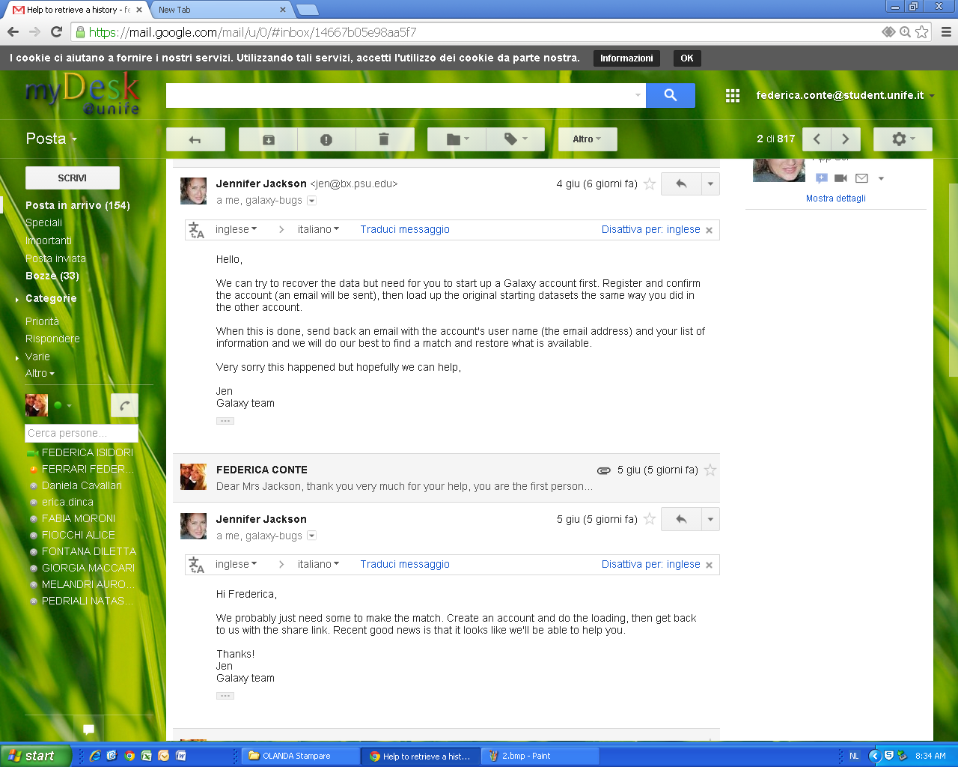

***Emails from Jennifer Jackson (Galaxy Admin)***

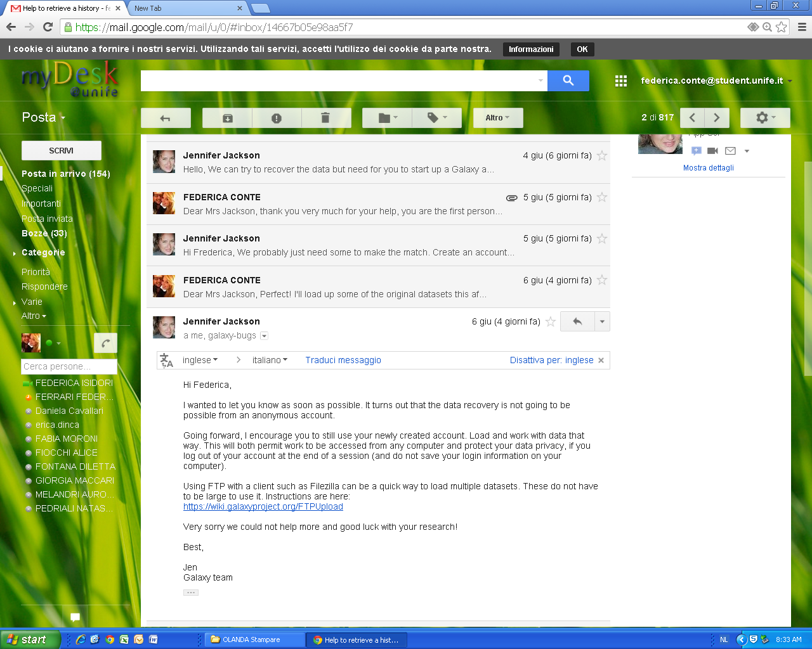

***Email from Jennifer Jackson (Galaxy Admin)***

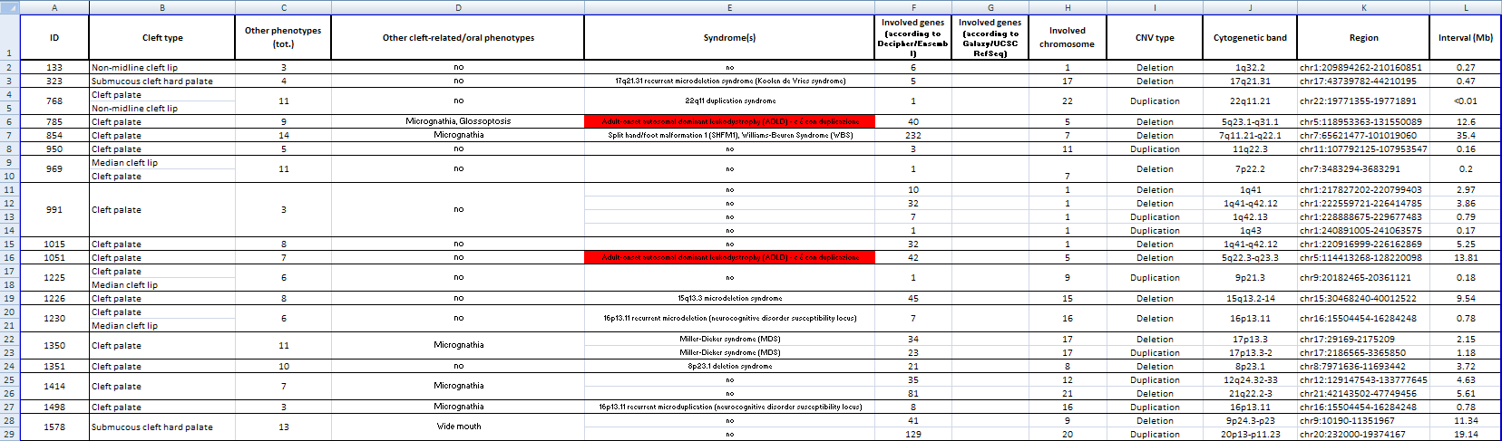***Excel file editing***

*Dentistry Dept. meeting, June 10th*