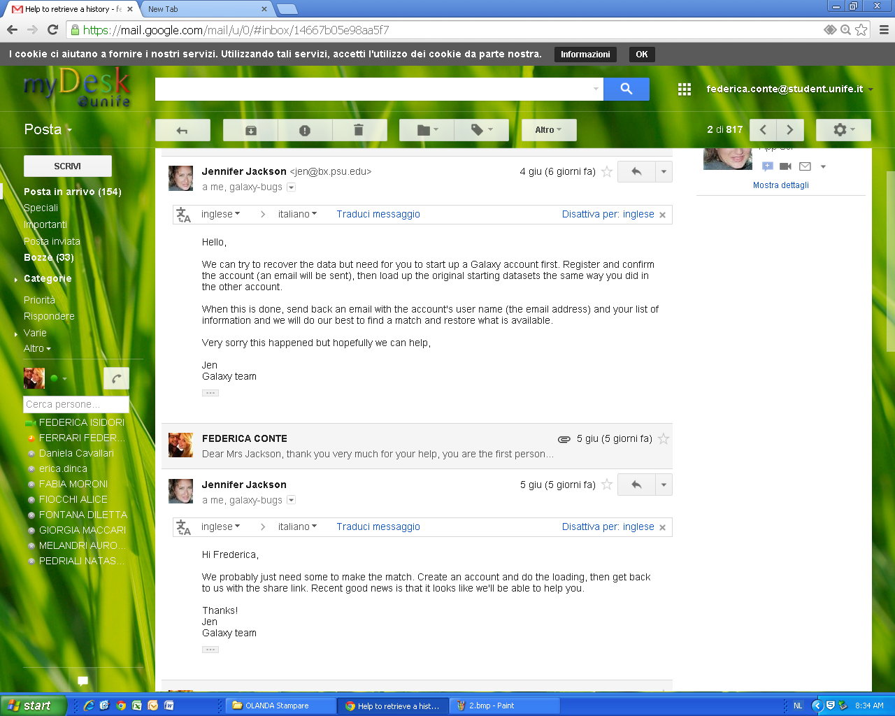
Emails from Jennifer Jackson (Galaxy Admin)
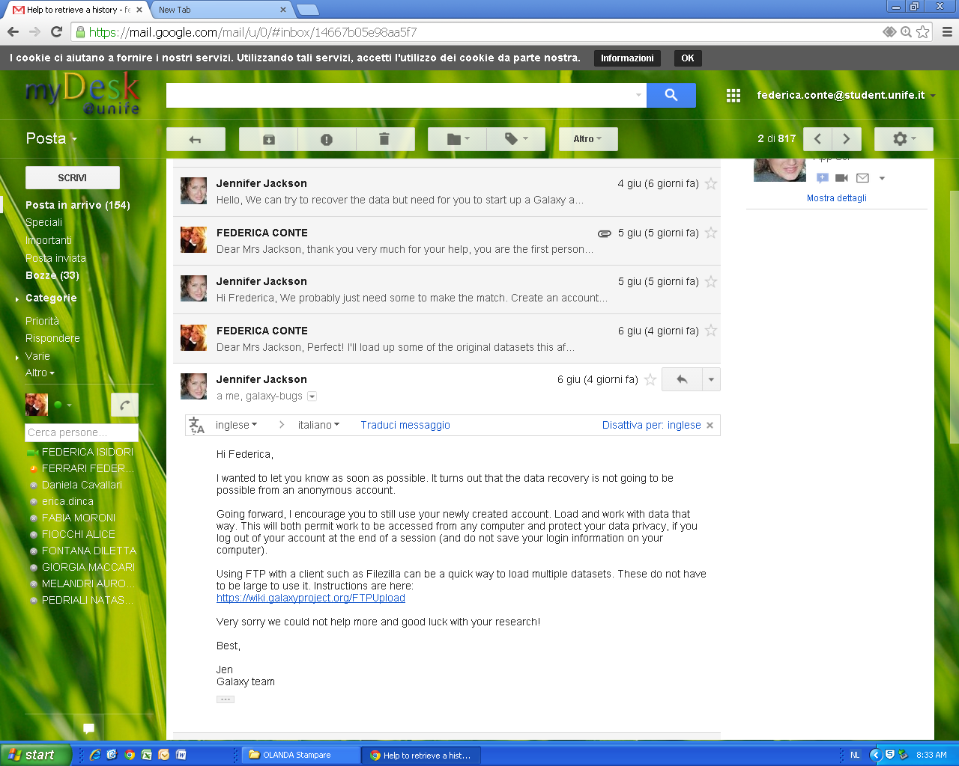
Email from Jennifer Jackson (Galaxy Admin)
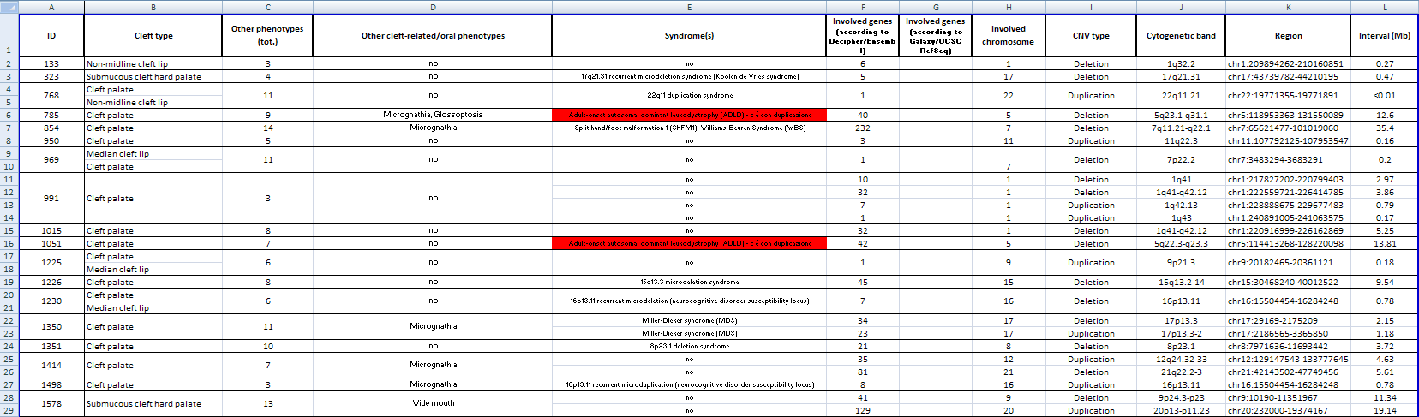
Excel file editing
Dentistry Dept. meeting, June 10th

