Liftover between different Genome assemblies (hg18 to hg19)

LiftOver tool : liftover - converts genome coordinates and genome annotation files between assemblies. The current version supports both forward and reverse conversions, as well as conversions between selected species. It’s useful to remapping features into another assembly.
Here it is presented an adapted version for how to remap a feature from NCBI36/hg18 to GRCh37/hg19 using UCSC’s liftOver tool.

Important: Please make sure you know in advance the assembly to which your aberration data is currently mapped to. If by mistake you remap an aberration already in GRCh37 to GRCh37 you will get new coordinates for the region mapped to the wrong coordinates.

UCSC’s Genome Browser provides a web facility to convert coordinates from one assembly into another. To convert coordinates using their liftOver tool do the following:
- Make sure that your data is in BED format, e.g. “chr3 100000 999990 myPatientId0000123” → aberration in NCBI36/hg18
- Note that each field is separated by a tab and each line by a character return. Please follow this strictly or the remapping tool may throw an error.
- Add as many lines as aberrations you would like to remap.
- Go to the liftOver page.
- Select “Original Assembly” Mar. 2006 (NCBI36/hg18) and “New Assembly” Feb. 2009 (GRCh37/hg19).
- Leave all other parameters (Minimum ratio of bases that must remap, etc…) with default values.
- Paste your aberration in the input box where it says “Paste in data” and hit submit.
Otherwise, upload your file containing the aberrations clicking on “Choose file” and hit submit.

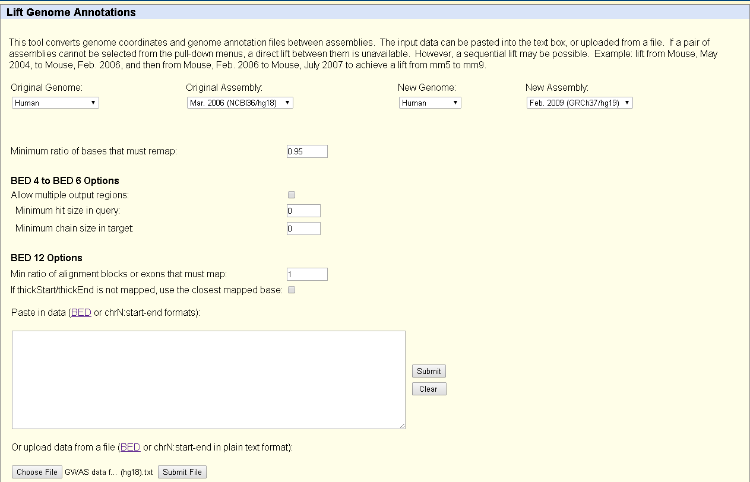

- To get results, scroll down the page and click on the “View Conversions” link.
- Here is the result I get: “chr3 125000 1024990 myPatientId0000123”

Please note that your feature may not remap because the region is partially or entirely deleted in the new assembly or split in GRCh37. In this case I recommend that you use another start or end point position, maybe use the start/end of alternative probes until you find a region where it maps. Another possibility would be to look at the genes for the region in the old assembly and select a region in GRCh37 that includes the same genes as in NCBI36. Each of these solutions require careful deliberation and may not be applicable to your particular case (e.g. genes in different chromosomes would not allow remapping based on genes).

Sources: http://crazyhottommy.blogspot.nl/2013/04/liftover-between-different-genome.html
http://manuelcorpas.com/2011/02/02/838/

