FINAL REPORT
(F. Conte)

SCIENTIFIC BACKGROUND AND AIM OF THE VISIT

Genetic studies of orofacial clefts (especially cleft lip and/or palate, CL/P, and cleft palate only, CPO) in combination with other malformations have identified a number of causative genes. These genes, however, only explain a low percentage of OFC cases, suggesting that novel disease mechanisms are still waiting to be discovered.
Current genetic studies, such as exome sequencing, are focused mainly on the coding regions that occupy about 2% of the genome. Considering cleft lip and/or palate (CL/P), so far a limited number of CL/P genes have been identified by exome sequencing, mainly in syndromic forms. For the more common sporadic CL/P, genome-wide association studies (GWAS) are often applied. These studies implicated variants in many genomic loci contributing to the risk of CL/P by statistical analysis, and majority of these variants are located in the non-coding regions of the genome. Indeed, these non-coding regions could contain regulatory DNA elements (REs) which may play an important role in OFCs etiology, as REs in the non-coding regions are required for proper control of gene expression either as enhancers or as repressors during embryogenesis. Disruption of REs that causes malformations, including OFCs, has been shown in several examples.
Unfortunately, sometimes is not easy to assess whether a gene or a RE is the cause of a defects or disease: in some cases, the patients show a deletion or duplication of a wide genomic sequence which contains several different genes and REs. These large alterations, called genomic copy number variations (CNVs), have been reported to associate with syndromic and non-syndromic forms of OFCs using various genetics analyses such classical FISH, CGH arrays or more recently SNP arrays (FitzPatrick et al., 2003; Mulatinho et al., 2008; Barber et al., 2013; Izzo et al., 2013). Most of these studies are reports of single cases with large genomic variants in which the causative genes or REs are often not clear. With the current development of genomics and diagnostic tools, CNV data of patients are accumulating and many are deposited in online databases. Therefore, a systematic analysis of all reported CNVs associated with OFCs may identify common genomic regions and shed lights on causative elements and common molecular pathways involved in OFCs.
Considering this background, the main idea of our project is to set up an original and no-cost bioinformatic approach to predict genes and REs that can play a rule in OFC etiology, by comparing and intersecting CNV regions found in OFC patients recorded in two online CNV databases, DECIPHER and ECARUCA. Afterwards, to prove the contribution of those genes and REs in cleft development, we have planned to proceed with functional validation, based on different approaches both in vitro and in vivo (Fig.1).

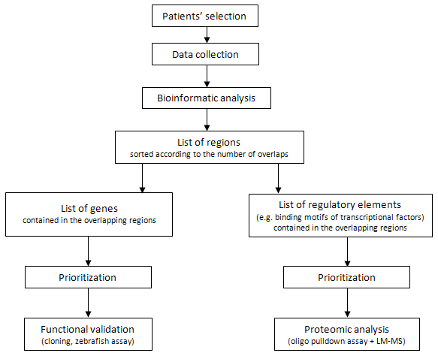

Fig.1: Project workflow.

WORK DESCRIPTION AND RESULTS

Bioinformatic analysis
- Data bases used in the analysis

Patients included in our study were retrieved from two freely-available CNV databases: DECIPHER and ECARUCA.
DECIPHER (https://decipher.sanger.ac.uk/) is a specific database of chromosomal imbalance and phenotype in human, based on Ensembl Resources. Contributing to DECIPHER is an International Consortium of more than 200 academic clinical centers of genetic medicine and 1600 clinical geneticists and diagnostic laboratory scientists, belonging to 30 different Countries (Bragin et al., 2014). At the time of writing this report, in this database are recorded more than 10,000 clinic cases and over 25,000 patients: of these, about 300 patients present cleft phenotype, including CL, CLP, CPO, alveolar ridge cleft and other types.
Similarly, ECARUCA (European Cytogeneticists Association Register of Unbalanced Chromosome Aberrations, www.ecaruca.net) is another CNV database that collects and provides detailed clinical and molecular information on rare unbalanced chromosome aberrations. So far, ECARUCA contains over 4800 cases with a total of more than 6600 genetic aberrations and has over 3000 account holders worldwide (Vulto-van Silfhout et al., 2013). In these second database we found only 17 OFC patients with CNV array data available.

- Data collection

The first step of our project was selecting the patients considering their orofacial cleft phenotype and the availability of for their CNV data . So far, our study includes 312 patients affected by OFCs (Table 1), 295 from DECIPHER and 17 from ECARUCA. Their genomic CNV regions were analyzed in order to look for overlapping regions (common deleted or duplicated regions). Although the etiologic basis and developmental processes can vary depending on the cleft type, initially we decided to include patients with different OFCs (mixed population) in order to improve the cohort. Nevertheless, we still have the possibility to sort the patients according to their cleft type or the presence of syndromes, and apply the same bioinformatic protocol for genes and regulatory elements identification on these smaller groups.

Phenotypes | Num. of patients | More info
Cleft lip (CL) | 26 | One patient is affected by lower lip cleft
Cleft palate (CPO) | 186
CPO + Bifid uvula | 8
Cleft lip and palate (CPL) | 41 | One patient is affected by CLP + cleft mandible
CLP + Bifid uvula | 1
Bifid uvula | 30
Oral cleft (unspecified) | 10
Facial cleft (unspecified) | 1
Facial cleft (unspecified) + CP | 1
Alveolar ridge cleft | 2
Alveolar ridge cleft + CL | 3
Alveolar ridge cleft + CPO | 1
Cleft mandible + CL | 2

Tab.1: Cohort of OFC patients (312) recorded in DECIPHER and ECARUCA databases. The classification is based on
their cleft phenotypes, which refer to the data inserted by the clinicians in those databases. For improving the
cohort, we have decided to consider a mixed population, including patients with different types of OFCs.

After the selecting the relevant patients, I gathered patients’ details (ID num., cleft type and other phenotypes, presence of syndromes) and CNV information (CNV type, genomic location, dimension, num. of involved genes, hypnotized pathogenicity contribution) from the databases. Subsequently, patients’ CNVs were grouped in two lists based on the type, deletion (DEL) or duplication (DUP), in order to work with them separately.

- Analysis of overlapping genomic regions
Afterwards, to identify overlapping genomic regions in these patients’ CNVs, Galaxy platform has been used. The term overlapping regions are indicated in Fig.2.

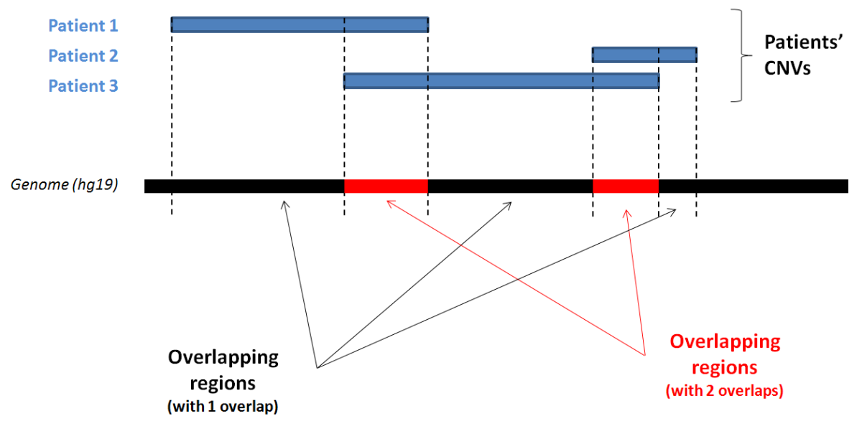

Fig.2: Example of overlapping process.

Two lists of overlapping genomic regions (one for overlapping DELs and one for overlapping DUPs) were generated, comprising of their genomic coordinates and number of overlaps.
As the overlapping regions with the more overlaps should be the most interesting ones, I sorted them according to the number of overlaps, .

As the overlapping regions are in general large and contain both coding and non-coding sequences, I analyzed both coding and non-coding regions separately in order to search for genes and regulatory elements (Fig.1).

- Gene selection

The genes contained in the overlapping regions were determined by combining UCSC Table Browser (assembly GRCh37/hg19) and Galaxy tools. In this way, a list of RefSeq genes that are either deleted (5812) or duplicated (5941) in CNVs was generated (Fig.3).
Genes in the list were prioritized based on the number of patients who carry these CNVs and the size of the genomic regions of these CNVs. Firstly, genes that are deleted or duplicated in only one patient were excluded. Subsequently, genes in overlapping regions that contain less than 5 genes in total are prioritized compared tothose in overlapping regions containing 6 or more genes (arbitrary cut-off value). In theory, the regions with a high number of overlaps and a low number of genes should be more informative that the regions overlapped by a few patients or containing many genes.

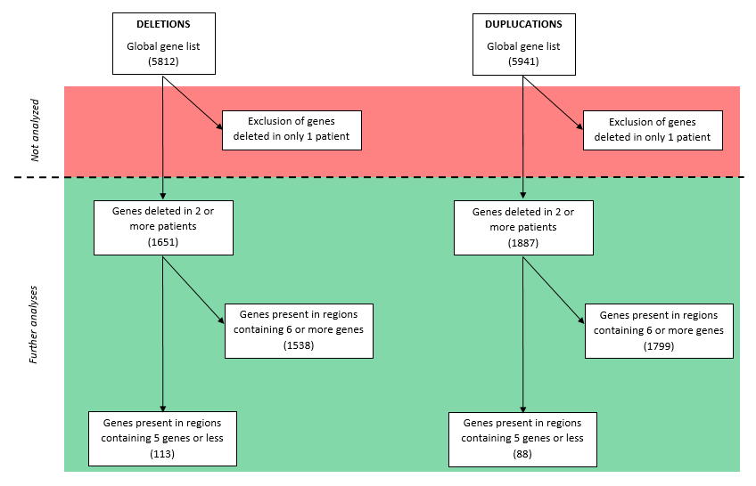

Fig.3: Prioritization and selection process applied to the gene lists derived from overlapping deletions and overlapping duplications.

The resulting lists were prioritized using ENDEAVOUR (http://www.esat.kuleuven.be/endeavour), an online tool for prioritizing variants based on the prediction of candidates by analyzing inherent sequence characteristics of genes, sequence similarity to known disease genes and functional annotation of candidate genes. To run the prioritization, this software required a training-list composed of reference genes: in our case, we chose a set of genes that have been proved to be related with OFCs development. Then, the analysis was run on the basis of a three step algorithm: (1) the program collected all the data about pathways and diseases in which the genes are involved, accessing up to twenty sources (to mention a few: GeneOntology, SwissProt, BioGrid interactions, ProspectR, BLAST score protein, etc.); (2) for each source, the candidates were ranked according to their similarities, so a set of n rankings was generated (one per data source); (3) the n rankings were combined into one global prioritization list of candidate using the order statistics.

From the resulting prioritized lists of genes, the first 25 genes were further analyzed (Tab.2), by examining whether these genes were known OFC genes (PubMed, OMIM) and, if not, the presence of known OFC genes in the same regions On the top of the gene lists we found several known cleft-related genes (e.g. TBX1, SATB2, MEIS2, etc…), which demonstrate that our methodology can identify OFC causative genes. Interestingly, we also identified some novel genes that are not yet known to associate with OFCs.

From DELETIONS |  |  | From DUPLICATIONS
Rank | Genes |  | Rank | Genes
1 | MEIS2 |  | 1 | TBX1
2 | SATB2 |  | 2 | TBX6
3 | FGF2 |  | 3 | IGF1R
4 | THBS1 |  | 4 | RGS7
5 | PPFIBP1 |  | 5 | MAPK3
6 | PASK |  | 6 | FH
7 | NCKAP1 |  | 7 | CIITA
8 | ZMYND11 |  | 8 | PPP4C
9 | ARNTL2 |  | 9 | CYFIP1
10 | TSHZ1 |  | 10 | PSMD13
11 | SEPT2 |  | 11 | NIPA1
12 | SPN |  | 12 | ABCC6
13 | DNAJC10 |  | 13 | SPN
14 | FRZB |  | 14 | CTSB
15 | CD28 |  | 15 | YES1
16 | SPRY1 |  | 16 | TLR3
17 | WHSC1 |  | 17 | ADCYAP1
18 | PARD3B |  | 18 | CYP4V2
19 | AGA |  | 19 | IL1RAPL1
20 | ABCA3 |  | 20 | SIRT3
21 | NELFA|WHSC2 |  | 21 | USP18
22 | ICOS |  | 22 | TXNRD2
23 | DPH6|ATPBD4 |  | 23 | OCA2
24 | DUSP19 |  | 24 | DGCR6
25 | H3F3A |  | 25 | GNB1L

Tab.2: First 25 top genes from overlapping deletions and overlapping duplications.

The names highlighted in bold indicate the already published OFC related genes.

In addition, others databases were used to further investigate the function of these top genes, such as DAVID (Database for Annotation, Visualization and Integrated Discovery, david.abcc.ncifcrf.gov/) and GeneCards (www.genecards.org/), and others to verify the availability of KO mouse models, like MGI (www.informatics.jax.org/) and IMSR (www.findmice.org/).

To check also expression of these genes in orofacial development, I assessed RNA-seq data generated by Prof. M.Dixon’s group (Manchester Academic Health Sciences Centre, University of Manchester).

TABLE FROM EXCEL (I’m modifying it to make it fits in a word page)

Finally, using p53FamTag database and many ChIP-seq datasets generated in the host lab (Dr. E.Kouwenhoeven), I checked whether these top candidates genes were directly regulated by p63, a trascriptional factor belonging to p53 family, which has been demostrated to cause CL/P.

RESULTS NEXT WEEK

Moreover, the lists of candidate genes were applied to two downstream analyses, to cross-check genes identified with other techniques: (a) cross-examination between these prioritized gene lists of and the candidates identified by exome-seq analysis carried out on 10 Dutch cleft families in the host lab (Dr. C.Ockeloen, Dr. K.Khandelwal); (b) cross-checking of overlapping regions and GWAS dataset (Dr. K.Khandelwal). The principle was to investigate the presence of shared genes, because the genes identified by both methods are likely to be relevant for OFCs.

Moreover, several miRNA genes were present in our high priority lists, suggesting their possible associations with cleft-related processes, such as embryo morphogenesis, neural tube development, cell migration and proliferation, skeletal development. To verify this hypothesis, initially we have planned to use different bioinformatics tools and miRNA databases to collect data systematically and then, after a prioritization process similar to the one used for genes, some interesting miRNA (if present) could be selected for the functional validation.

- Regulatory element selection

To understand whether the overlapping genomic CNV regions contain regulatory elements, especially those regulated by p63, I performed analysis to search for p63-bound regulatory elements by using an existing BED-Tools (Linux) and p63 ChIP-seq datasets in the host lab (Dr. E.Kouwenhoeven, Dr K.Khandelwal).
It has been shown that p63 binding sites can drive expression of genes relevant to orofacial development and are important to etiology of OFCs (Thomason et al., 2010; Fakhouri et al., 2013). For regulatory elements in the GWAS regions, approximately 100-200 p63 binding sites have been identified in GWAS regions and near CL/P genes. In order to be functional, a binding site has to contain a specific binding motif, which is a short consensus sequence recognizable by specific proteins, especially transcriptional factors, thanks to their DNA-binding domains (DBDs).
In general, the binding motif sequence recognized by p63 is composed of 19 nt, four of them highly conserved among species: C (5nt), G (8nt), C (15nt) and G (18nt).

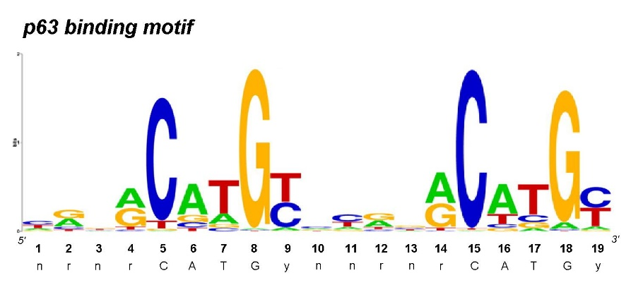

Fig.4: p63 consensus binding motif identified from 11,329 binding sites (Wolchinsky et al., 2014).

Last year Dr.K.Khandelwal selected from all predicted p63 binding sites those ones containing SNPs in any of four importan positions: intersecting her dataset with my list of overlapping regions, several shared p63 binding motifs came out (Tab.4), subsequently prioritized according to the number of overlaps of the region which they belonged to.

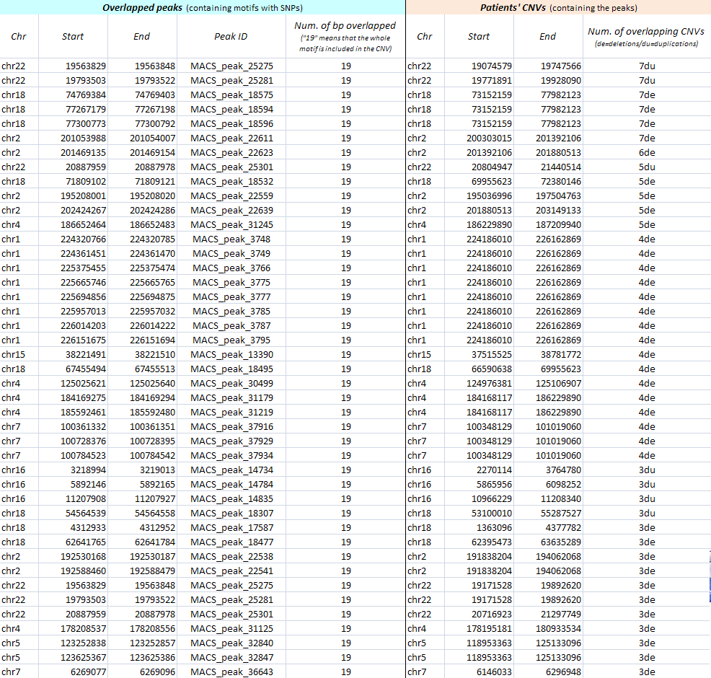

Tab.3: List of p63 binding motifs belonged to the overlapping regions with the highest number of
overlaps (from 8 to 3). (In column I: “de” indicates deletions and “du” indicates duplications).

Concerning that, our future plans consist in selecting p63 binding motifs containing SNPs in linkage disquilibrium with OFCs, and investigating the mutation effects on p63 bound and activity with proteomic approaches (e.g. oligo pulldown assay followed by mass spectrometry).

Oligo pulldown assay (+ Mass Spectrometry) protocol establishing

As mentioned previously, we showed that p63 binding sites/motif identified by ChIP-seq analysis of p63 in epithelial cells are relevant to etiology of OFCs (Thomason et al., 2010) and this point justifies our decision to start establishing the oligo pulldown assay protocol using a p63 binding motifs.

The DNA pulldown assay is a method used to selectively detecting all the DNA-binding proteins which bind a specific sequence of DNA. Typically, the DNA oligo are labeled with biotin, useful after the incubation with oro-epithelial cell nuclear extract for recovering the oligo and all the proteins bound on it by using immobilized sepharose beads coated with streptavidin. After the separation, the peptides bound to the sequence are eluted from the oligo and analyzed by western blot or, as in our case, by mass spectrometry (LM-MS). The mass spectrometry detection is a new and highly sensitive method whose outcome is a list of all the DNA-binding factors which bind the oligo sequence. So far, two different LM-MS protocols are available in the host lab: the “single sample protocol”, in which each reaction takes place in one well and remains separated from the others until the ending phase, and the “combined samples protocol”, in which the reaction containing the WT oligo (wt motif) and the reaction containing the MUT oligo (mutant motif) are mixed after a differential labelling phase. In our case, we used the so called “combined samples” protocol and the final outcome is a list of binding factors based on ratio of their bounds. In other words, the LM-MS device measures for each peptide the strength of its bound to the WT oligo (control) and the strength its bound to the MUT oligo.
OR
In other words, the LM-MS device measures for each peptide the strength with which it binds the WT oligo (control) and the strength with which it binds the MUT oligo.strength of its bound to the WT oligo.
Then, the transcription factors bound at specific genomic regions with different genotypes can be compared and rationalized with the underlying genomic sequences.

However, before to start with the oligo pulldown, I encountered a problem of low efficiency in the nuclear extraction phase. In the host lab a nuclear extraction protocol was already standardized but it had been set up for cancer cells. On the contrary, the cell type designated for our experiment was gingival keratinocytes (GKs) from healthy subject biopsies (primary culture).
In general, GKs are less proliferative than standard cancel cell lines. Moreover, GKs nuclei are smaller than the cancer cell nuclei, suggesting that also the amount of nuclear material is lower. For all these reasons, we decided to modify and adapt both the culture conditions and nuclear extraction protocol, in order to optimize the efficiency for reaching a higher amount of GK nuclear extract (Tab.4).

GKs primary culture protocol, modifications:
increasing of medium amount per Petri dish (15cm²) during the culturing.
increasing of the frequency of medium refreshing (every day, starting from day 5).
Nuclear extraction protocol, modifications:
increasing the amount of trypsin to cover homogenously all the surface for detaching GKs, and to avoid the use of cell lifter.
increasing the time of trypsinization.
doubling the steps of dish rinsing after trysinization.
increasing the volume of fresh medium to block the reaction after trypsinization.
Increasing the number or douncer strokes during mechanical lysis of GKs

Tab.4: Modifications of primary culture and nuclear extraction protocols for gingival keratinocytes.

In conclusion, considering a concentration of 5 mg/ml of nuclear protein as the optimum, I was able to reach a concentration of 4.8 mg/ml (fluorometric quantitation at A = 595nm).

I started to work on oligo pulldown assay followed by mass spectrometry for adapting the protocol
to our experimental conditions. The p63 binding motif chosen for testing the host lab oligo pulldown protocol was selected by Dr.K.Khandelwal because affected by a SNP at one of the important positions (nt 13) in LD with a GWAS locus.
Based on that, we designed the three oligo pairs containing : (a) wildtype p63 binding motif (WT oligo); (b) all four conserved Cs and Gs (Fig. 4) mutated(AM oligo); (c) the SNPaffecting C/G (the position) (SNP oligo). The samples with the different oligos where organaized as follows: (1) WT oligo reaction mixed with SNP oligo reaction; (2) WT oligo reaction mixed with AM oligo reaction. Before the sample mixing, all the reactions were differentially labelled to make the peptides distinguishable (Fig.4).

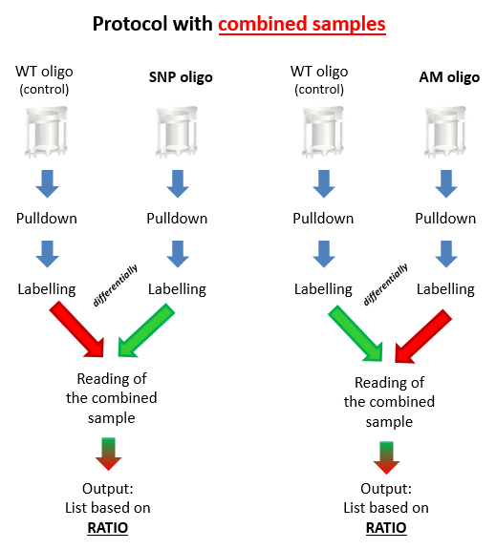

Fig.4: Workflow of oligo pulldown followed by LM-MS (“combined samples” protocol).

The result of the experiment “WT oligo vs. SNP oligo” showed many DNA-binding factors bound to the wildtype p63 motifi sequence and, among these, p63 was a significant outlier (Fig.5). This shows that p63 binds tothe WT motif preferentially in comparison to the motif containing the SNP.

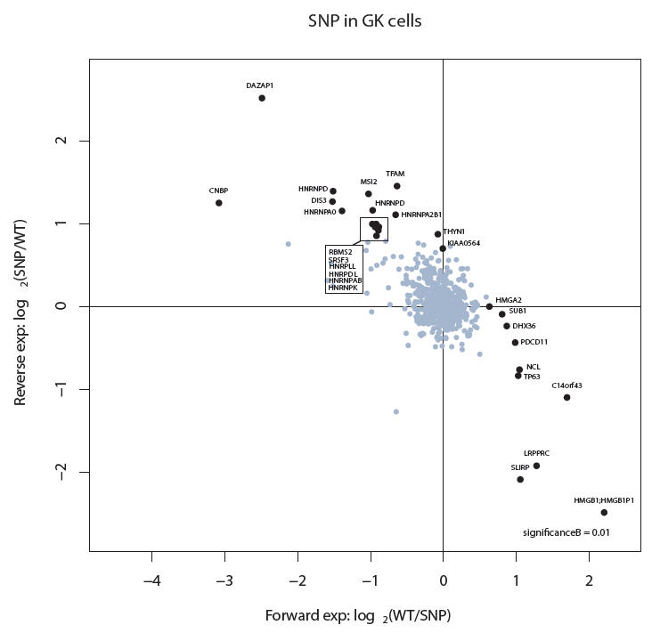

Fig.5: The experiment “WT vs. SNP” was repeated twice: once for the forward experiment and once for the reverse experiment. The North-West quadrant represents the location of all the DNA-binding proteins that bound preferentially the SNP oligo. On the other hand, the South-East quadrant contains the DNA-binding proteins that bound preferentially the WT (control) oligo. The background cloud located in the middle of the axes contained the DNA-binding proteins which bound equally both the control and the mutant, and also the factors which didn’t bind anything. The outliers spots in the quadrant represents the interesting factors (significance = 0.01). Usually the RNA-binding proteins jumps out randomly as outliers. In this case, TP63 is located in the WT quadrant (red arrow) as a significant outlier, confirming what we expected.

Unfortunately, the plot from the experiment “WT oligo vs. AM oligo” was not so clear and, although p63 was present in the WT quadrant as expected, it was not a significant outlier. For this reason, I performed this experiment other three times but still the resulting plots were not optimal (Fig.6).

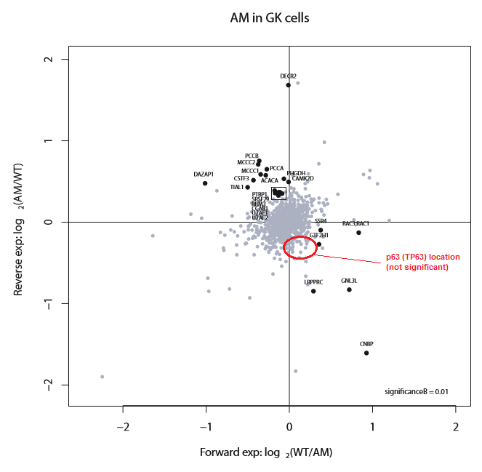

Fig.6: Plot from the third attempt of the experiment “WT vs. AM”. In this case the reaction was performed twice: once for the forward experiment and once for the reverse experiment. The North-West quadrant represents the location of all the DNA-binding proteins that bound preferentially the AM oligo. On the other hand, the South-East quadrant contains the DNA-binding proteins that bound preferentially the WT (control) oligo. The background cloud located in the middle of the axes contained the DNA-binding proteins which bound equally both the control and the mutant, and also the factors which didn’t bind anything. The outliers spots in the quadrant represents the interesting factors (significance = 0.01). Usually the RNA-binding proteins jumps out randomly as outliers. In this case, TP63 does not come out as a significant outlier in the WT quadrant but it is present in the background cloud.

In the following months, we would like to apply this technique systematically to investigate other p63 binding motifs, such as those identified by through the computational analysis in the overlapping regions. In addition, we will check carefully the lists of other DNA-binding factors that have bound the oligos containing p63 binding motif, to evaluate their REs similarity and possible cofactors. Concerning this aspect, another type of pulldown, the so called antibody pulldown assay, could be performed to identify the real cofactors of p63, which are still unknown.

General conclusion of your work

REFERENCES

Bragin E, Chatzimichali EA, Wright CF, Hurles ME, Firth HV, Bevan AP, Swaminathan GJ. DECIPHER: database for the interpretation of phenotype-linked plausibly pathogenic sequence and copy-number variation. Nucleic Acids Res. 2014 Jan;42(Database issue):D993-D1000.

Vulto-van Silfhout AT, van Ravenswaaij CM, Hehir-Kwa JY, Verwiel ET, Dirks R, van Vooren S, Schinzel A, de Vries BB, de Leeuw N. An update on ECARUCA, the European Cytogeneticists Association Register of Unbalanced Chromosome Aberrations. Eur J Med Genet. 2013 Sep;56(9):471-4.

FitzPatrick DR, Carr IM, McLaren L, Leek JP, Wightman P, Williamson K, Gautier P, McGill N, Hayward C, Firth H, Markham AF, Fantes JA, Bonthron DT. Identification of SATB2 as the cleft palate gene on 2q32-q33. Hum Mol Genet. 2003 Oct 1;12(19):2491-501.

Mulatinho M, Llerena J, Leren TP, Rao PN, Quintero-Rivera F. Deletion (1)(p32.2-p32.3) detected by array-CGH in a patient with developmental delay/mental retardation, dysmorphic features and low cholesterol: A new microdeletion syndrome? Am J Med Genet A. 2008 Sep 1;146A(17):2284-90.

Barber JC1, Rosenfeld JA, Foulds N, Laird S, Bateman MS, Thomas NS, Baker S, Maloney VK, Anilkumar A, Smith WE, Banks V, Ellingwood S, Kharbutli Y, Mehta L, Eddleman KA, Marble M, Zambrano R, Crolla JA, Lamb AN. 8p23.1 duplication syndrome; common, confirmed, and novel features in six further patients. Am J Med Genet A. 2013 Mar;161A(3):487-500.

Izzo G, Freitas ÉL, Krepischi AC, Pearson PL, Vasques LR, Passos-Bueno MR, Bertola DR, Rosenberg C. A microduplication of 5p15.33 reveals CLPTM1L as a candidate gene for cleft lip and palate. Eur J Med Genet. 2013 Apr;56(4):222-5.

Thomason HA, Zhou H, Kouwenhoven EN, Dotto GP, Restivo G, Nguyen BC, Little H, Dixon MJ, van Bokhoven H, Dixon J. Cooperation between the transcription factors p63 and IRF6 is essential to prevent cleft palate in mice. J Clin Invest. 2010 May;120(5):1561-9.

Wolchinsky Z, Shivtiel S, Kouwenhoven EN, Putin D, Sprecher E, Zhou H, Rouleau M, Aberdam D. Angiomodulin is required for cardiogenesis of embryonic stem cells and is maintained by a feedback loop network of p63 and Activin-A. Stem Cell Res. 2014 Jan;12(1):49-59.

