Recap with correction - How to identify the regions with the higher number of overlaps using Galaxy

(correction after step 5, shown in green)

My goal is to get a file with five columns organized as follows:

Chr Start End N. overlaps Patient IDs whose CNV regions overlaps

of the overlapping regions

And then sorted this table according to the n. of overlaps to get a kind of ranking
(prioritization according to the number of overlaps).

1 – Load the file with the original dataset

2 – Click on “Sort data in ascending or descending order” and sort the original dataset according to the chromosomes (necessary for step 3).

3 – Click on “Create a BedGraph of genome coverage”.
In the output file you can see: chr (column1), start (c2), end (c3), number of overlaps (c4) but not the patient IDs.

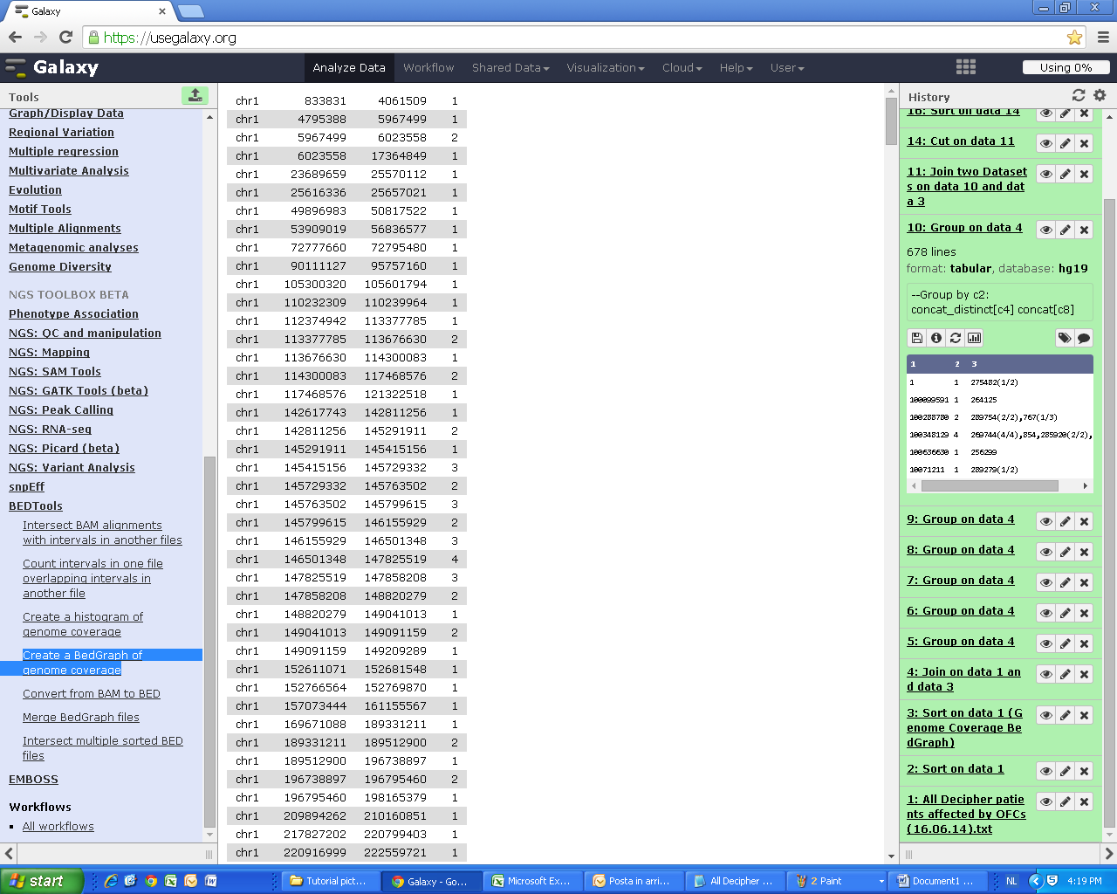
Example with five regions

4 – Select “Join the intervals of two datasets side-by-side” and join dataset ‘3’ and ‘1’.
In the output file you can see:
chr (c1), start (c2), end (c3) of the overlapping regions
number of overlaps in that regions (c4)
chr (c5), start (c6), end (c7) of the original regions (I mean the regions with CNV of the patients)
patient ID (c8)

Note: the regions that overlap are split in two rows(see the orange arrows)... need to group the data!

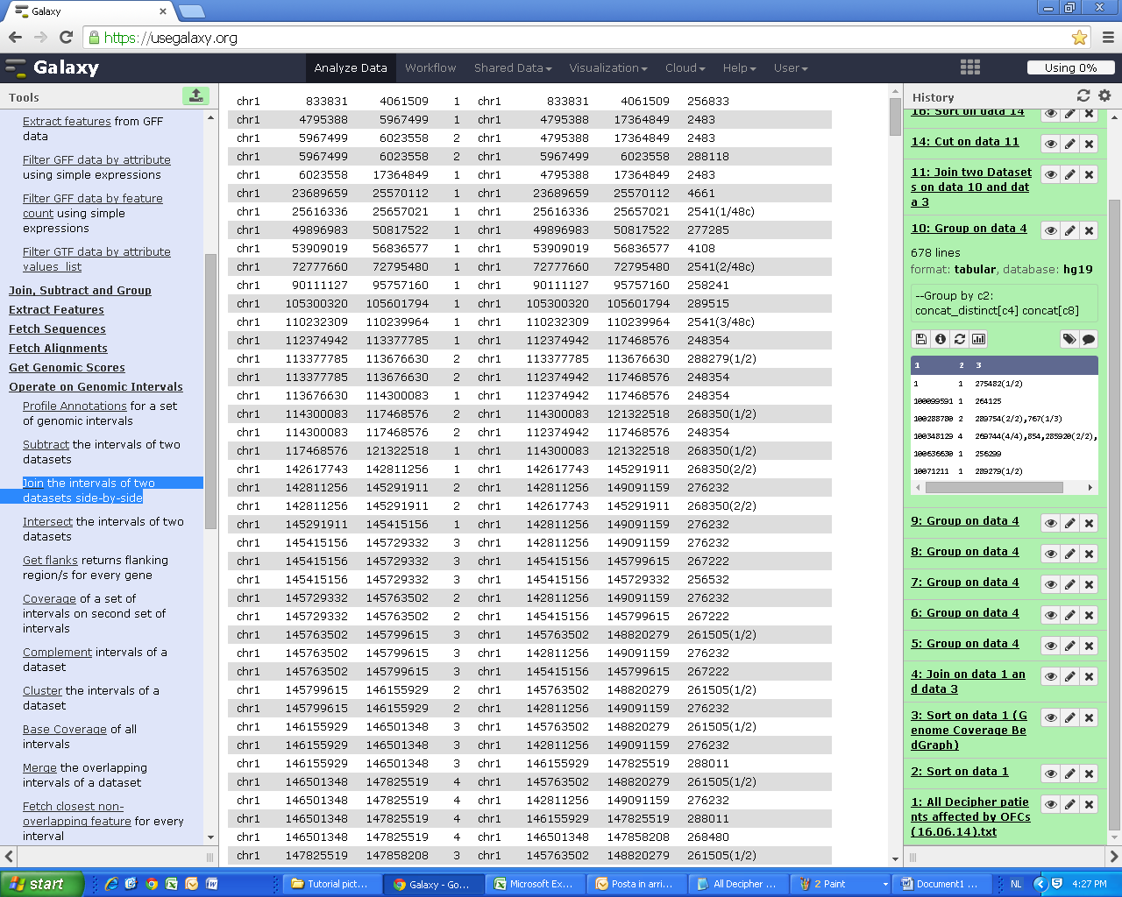
Example with five regions

5 – Group on dataset ‘4’ by column c4 (number of overlaps) and concatenate on column c8 (patient IDs). WRONG!

If I do this, Galaxy pools together all the IDs and the regions… (see the output file down below).
In this case: column1 contains the number of overlaps; column 2 contains all the IDs of the patients whose CNV regions overlap 1 time (or 2 times for the second row, etc…).

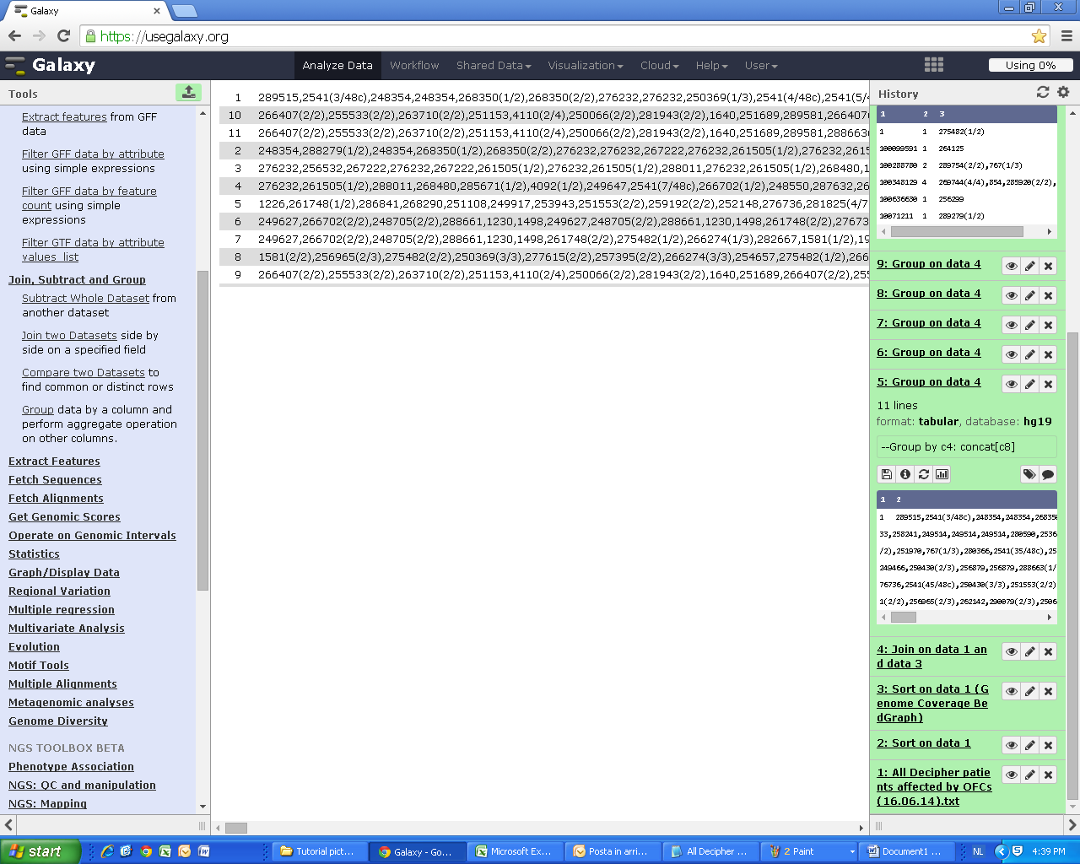

POSSIBLE SOLUTION (that works!)

5 – Group on dataset ‘4’by column c2 (start of the overlapping regions) with two operations:
concatenate distinct on c4 (num of overlaps) and concatenate on c8 (patient IDs).

6 – Join datasets ‘3’ (BEDGraph), using c2, and ‘5’, using c1.
In the output file there are two columns repeated (those columns I used before for grouping).

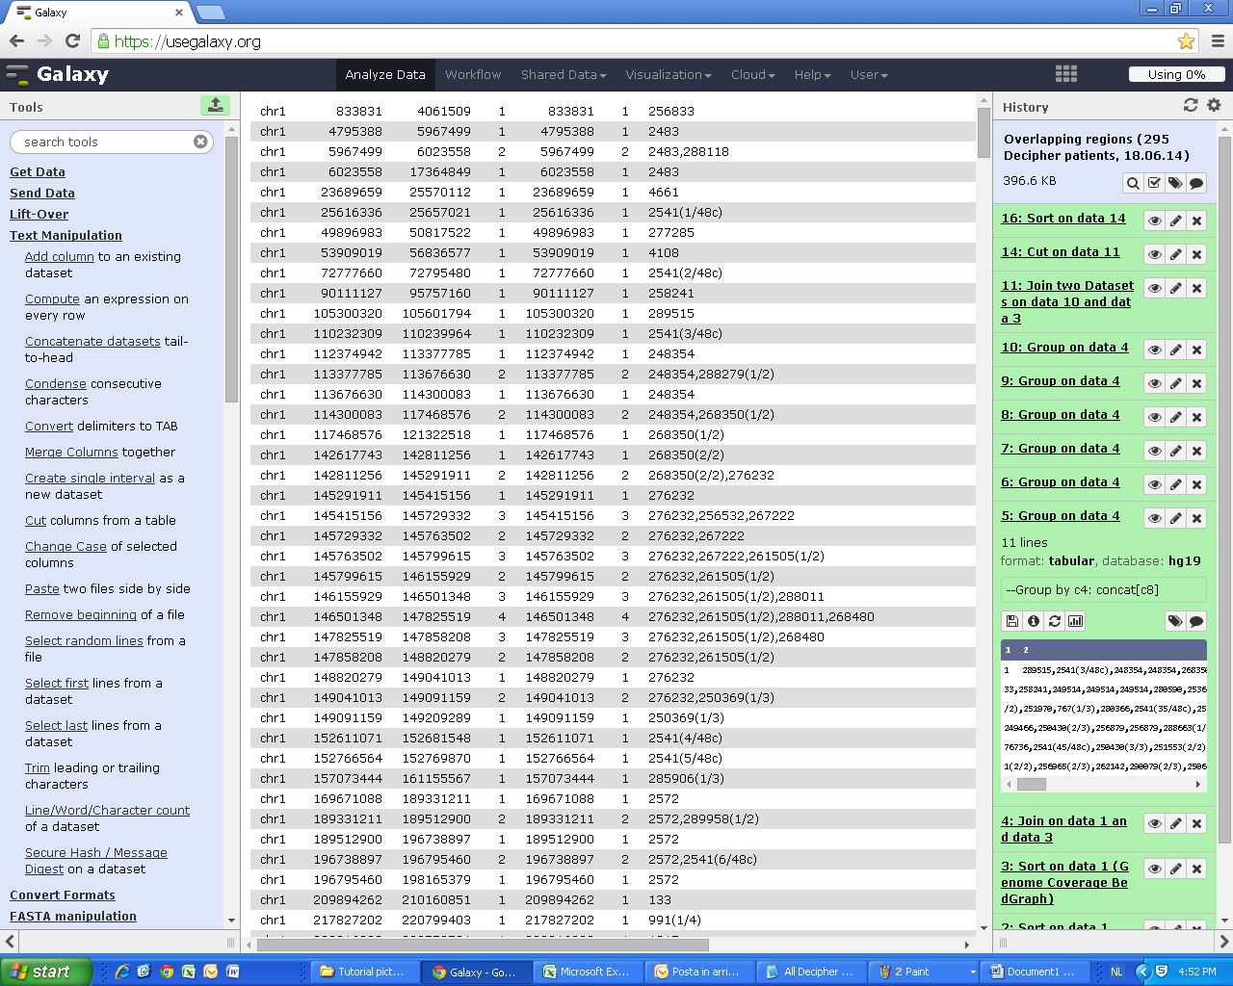

7 – Click on “Text Manipulation” and then on “Cut columns from a table”, to eliminate columns c5 and c6.
Cut columns: c1 (chr)
c2 (start)
c3 (end)
c4 (num of overlaps)
c7 (patient IDs whose CNV regions overlap)

This is the correct output file:

chr start end n. overlaps IDs
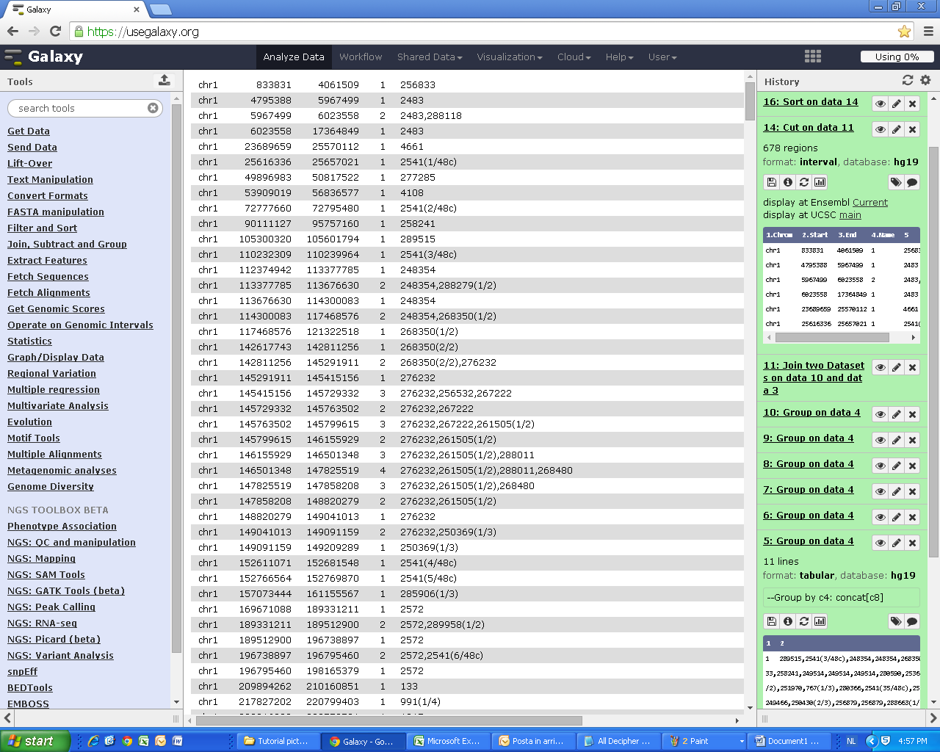

But the output file entries are still sorted according to the chromosomes and not to the number of overlaps… so I need to sort the dataset again!

8 – Sort according to the num. of overlaps to get a ranking (a kind of prioritization), using dataset ‘7’ on column c4 (num. o f overlaps).
The resulting output file it’s exactly what I want (chr / start / end / n. of overlaps / IDs):

